SOFTBALL

GENERAL RULES

The Official Special Olympics Sports Rules shall govern all Special Olympics softball competitions. As an international sports program, Special Olympics has developed these rules based upon Amateur Softball Association of America rules for softball. Amateur Softball Association of America rules shall be employed except when they are in conflict with the Official Special Olympics Sports Rules.
For more information, visit www.asasoftball.com.

OFFICIAL Events offered ATHLETES CAN COMPETE IN ONLY ONE EVENT!
1. Team Competition
2. Unified Sports Team Competition – Invitational only

MEDICAL DEADLINE AND PARTICIPANT ELIGIBILITY
Athletes must have active Medical Form AND Covid-19 Participant Release Form AND Communicable Disease Waiver on file with the Special Olympics WI State Office. Coaches and Unified Partners must have an active Class A Application, Covid-19 Participant Release form AND Communicable Disease Waiver on file. The Medical or Class A form must be received or postmarked by the deadline and remain valid through the end of Fall Games.

Section A – General Rules
- In cases not specifically covered by these rules, Amateur Softball Association Rules are employed except when in conflict with Special Olympics rules.

- Protests will only be considered for rule infractions (not for umpire judgments).
- The games rules committee shall make all final judgments.
- Teams must play a minimum of two (documented) games against other Special Olympics teams prior to registration for district competition. The team roster must remain the same for the two qualifying games, district competition and State competition. Teams that modify their rosters will forfeit all games. Qualifying games must be played against other teams. One game must be played against a team from another Local Program. Forfeited games do not count toward the scrimmage requirement.

Section B – Divisioning
- All teams will play as coed open teams following men's rules.

Section C - Field
- The field shall conform to ASA rules except when Special Olympics modifications apply.
- The softball diamond may vary with 60 - 65 foot base lines depending on venue availability for all ages and divisions. Coaches must indicate on their registration forms which distances have been used for assessment tests.

- The pitching distance will be 46 feet.

Section D – Equipment
- Only bats marked by the manufacturer as "Official Softball" may be used. All bats must be single wall. In addition, any bat that is not on the approved bat list shown on www.asasoftball.com/aboutcertified_equipment.asp will be considered illegal and may not be used for competition. Use of an illegal bat in a SOWI tournament may result in forfeiture of the game, and all following subsequent games in the tournament. This includes wooden bats which must be marked “official softball” and must be free of defects that might cause the bat to splinter.

- During warm-ups or during play, the catcher is required to wear a face mask and a batter's or catcher's helmet and a chest protector. Shin guards are strongly suggested for safety, but are not required.

- Fielder masks are mandatory for defensive players at 1st base, 3rd base, and pitchers during the duration of defensive play. Any defensive player can wear a face mask as well, but are not required to.

- Gloves are required. A first baseman's trapping style mitt may be worn by the first basemen or catchers only.

- A 30.5 cm (12’) restricted flight “official softball” with a COR of .52 and under shall be used. Colors shall be white or yellow (yellow is preferred for safety and visibility). High school fast pitch balls are not to be used (raised laces are a safety concern).

- Players with illegal uniforms will not be allowed to play. Legality and final approval of the uniform will be determined by the Event Coordinator or SOWI staff (not the Umpire). All players on a team must wear uniforms (shirts and pants) that are identical in color, trim and style. An Arabic number of contrasting color at least six inches high must be worn on the back of all uniform shirts. Taped numbers are not allowed. Team pants must either be all long or all short in style. If this must vary due to health or religious reasons, a Special Needs Form must be completed and prior approval from SOWI staff must be obtained. Ball caps, visors and headbands are optional for all players, and all must be worn properly. Player socks need not match. No jewelry is allowed. Teams who do not have the minimum required number of players with legal uniforms to field a team must forfeit.

- Batting helmets with two ear flaps and chin straps are required for all offensive players while batting and base running. The batter must wear the batting helmet at all times while still on the base paths. In addition, any player that intentionally removes their helmet while running the bases will automatically be called out. If at any time, a batter is caught without a helmet with a chin strap and a pitch has been delivered, the batter is out.

- Any athlete that acts in the capacity as a base coach must wear a batting helmet while coaching. They will not be allowed to coach if they do not / refuse to wear one.

SECTION E – UMPIRES AND THEIR DUTIES
- Umpires will conduct the games in accordance to specified rules.
- Regional, district, sectional and State competitions should utilize ASA certified umpires when possible.
- Officials shall have full authority to interpret rules. For further questions, the tournament rules committee shall be consulted.

- Officials shall have the power to make all decisions on any points not specifically covered in the rules.

- In case of injury, equipment repair, or unsafe playing conditions, the umpire shall stop play but time does not stop for any reason unless the umpire considers it to be excessive. The decision to stop time is at the umpire’s discretion.

- The umpire may call a game completed (for darkness or weather) after 4 1/2 innings if the home team is ahead in runs, or after five full innings.

Section F – Players and Substitutes
- Each team will consist of a minimum of 10 and maximum of 15 players on the roster in order to be eligible to be registered for competition.

- Shorthanded Rule – A team must have ten players to start a game. A team with less than ten players at game time must forfeit the game. The vacant position must be listed last in the batting order and an out will be taken each time the vacant position in the batting order appears. Teams must play with a full roster for at least one game at district to be eligible to advance.

- During play, due to injury or player disqualification, a team may play with as few as nine players. However, if a team is unable to field at least nine players, the game shall be forfeit. At no time can play continue with less than the minimum number of players.

- Substitutions may be made anytime the ball is dead. The umpire, scorekeepers and opposing coach must be notified by the coach.

- A starting player withdrawn may re-enter the game once. This player will maintain the same batting position in the line up when re-entering the game.

- A starting player may only re-enter for the same player substituted for him/her.
- Substitutes may not re-enter.
- An extra player, referred to as "EP" is optional, but if one is used, it must be made known prior to the start of the game and be listed on the scoring sheet in the regular batting order. If the EP is used, this designated position must be used the entire game. Failure to complete the game with the EP results in the forfeiture of the game.

- The EP must remain in the same position in the batting order for the game.
- If an EP is used, all 11 must bat and any 10 may play defense. Defensive positions may be changed, but the batting order must remain the same. Each half inning will consist of three outs or a maximum of 10 batters (Rule Section G, 3.a.).

- The EP may be substituted for at any time. The substitute must be a player who has not yet been in the game. The starting EP may re-enter.

- Courtesy Runners will be allowed as per the following rules:
  - A courtesy runner may only be used in the case of an injury.
  - The courtesy runner must be the athlete who completed the last out of the current or prior inning.
  - Only one courtesy runner may be used per inning.
  - If an injury causes a runner to leave the game after a courtesy runner has already been used in the inning, the player will be called out.

Section G – The Game
- A regulation game shall consist of seven innings or one hour of play. An equal amount of innings will be allowed for the losing team. (NOTE: No new inning may begin after the 55th minute of play.)

- The home team shall be decided by a coin toss at the beginning of the game.

- No stealing will be allowed. Base runners may not lead off but may leave the base once the pitched ball touches home plate, the home plate mat, or the pitch is swung at by the batter.
  - Each half inning will consist of a team's regulation line up batting order not to exceed 10 batters or three outs, whichever occurs first. NOTE: If you are using an EP and thus have 11 batters in your line up, only 10 batters will be allowed to bat in a half inning if three outs are not reached first.

  - Following the batted ball by the last batter, all players will be allowed to score until a defensive player in possession of the ball touches home plate or makes the third out. (NOTE: A last batter does not have to "hit" the ball.) Batters may not advance more than one base after a walk and only if forced to move by the walked batter.

- A game will be declared completed if one team has a 15-run lead after two innings, a 12-run lead after three innings, or a 10-run lead after four innings, or prior to the start of the last possible inning to be played because of the one-hour time limit.

- A game tied at the end of regulation play will be continued through an unspecified number of innings until a team is ahead at the end of a full inning.

- Each team will be allowed 10 minutes after the scheduled game time to take the field. If a team is not ready to take the field at the end of 10 minutes, the game will be forfeited.

- All line-up cards must be presented to the official scorekeeper 10 minutes before the start of any game.
- The infield-fly rule will be in effect at the discretion of the umpire(s).
- If a coach touches a runner while the ball is still in play, that runner will be declared out. Coaches are required to stay within the boundaries of the coaches' boxes (and in their bench area when on defense).

- A maximum of four coaches will be allowed on the bench during games.

Section H – Pitching Regulations
- A legal delivery shall be one delivered to the batter in underhand motion.
- The pitcher must take a position with both feet firmly on the ground and with one or both feet in contact with the pitcher’s plate.

- The pivot foot must remain in contact with rubber until the ball leaves the pitcher's hand.

- The ball must be delivered with a perceptible arc of at least six feet, but not more than 12 feet from the ground.

- The speed of the pitch will be left entirely to the judgment of the umpire.
- If the fielding team would like to intentionally walk the batter, the fielding team’s coach must notify the umpire prior to the first pitch of the at bat. The batter will advance to first base and there will be no pitches thrown for that at bat.

Section I – Batting Regulations
- Each player will bat in the order their name appears on the score sheet. A player batting out of order will be called out. If a batter is in the batter’s box and a pitch is made, it will be considered a legal “at bat” and the player will be called out for batting out of order. If the player is changed prior to a pitch being thrown, no out will be assessed.

- Balls will be called by the umpire. Strikes will be called for pitches swung at and missed, foul balls, and pitches within the strike zone but not swung at. [Strike zone consists of a legally pitched ball which hits home plate or the strike mat. (See diagram below.)] NOTE: The strike mat does not constitute home plate for the runner.
  - Diagram:

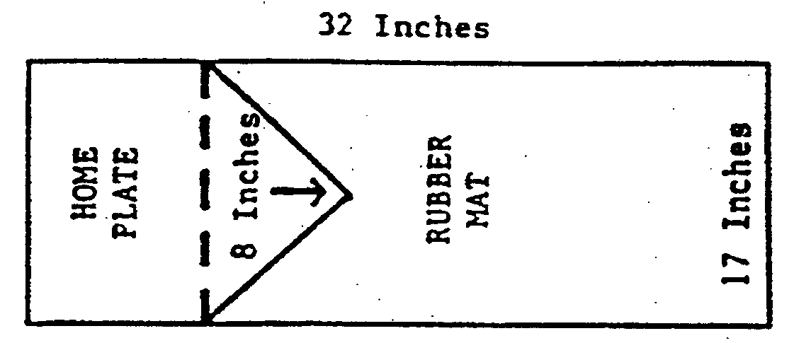
NOTE: The entire rectangle (17x32) is considered the strike zone.

- A batter will be out at the third strike.
- After two strikes, a foul ball will be considered a strike and the batter will be called out.
- A player will walk after four balls have been called.
- All players must remain on the bench unless they are the on-deck batter, the batter or in the field.

SECTION J – Unified SportS® Team Competition
- The roster shall contain a proportionate number of athletes and partners.
- During competition, the line-up shall never exceed five athletes and five partners (six athletes and six partners if the EP is used) at any time. Failure to adhere to the required ratio results in a forfeit.

- Each team shall have an adult non-playing coach responsible for line-up and conduct of the team during competition. Any team member may act as a base coach. Base coaches must remain in the appropriate marked area.

- The batting order shall be an alternation of athletes and partners.
- During competition the following position requirements are: two athletes and two partners in both the infield and outfield, and one athlete and one partner as pitcher and catcher.

- Unified Sports Softball Shorthanded Rule – A team may start a game with nine players if the line-up includes five athletes and four partners. Any other ratio will result in a forfeit. A team with less than nine players at game time must forfeit the game. The vacant position must be listed last in the batting order and an out will be taken each time the vacant position in the batting order appears. The position requirements must remain the same, except the outfield must now include two athletes and only one partner (two athletes in outfield, two in infield, and one at either pitcher or catcher).

The Softball Individual Skills Assessment and the Softball Score Sheets have been moved to the Appendix section of the Competition Guide

