VOLLEYBALL

GENERAL RULES

The Official Special Olympics Sports Rules shall govern all Special Olympics volleyball competitions. Special Olympics Wisconsin uses United States Volleyball (USVB) rules. USVB rules shall be employed except when they are in conflict with the Official Special Olympics Sports Rules.

OFFICIAL EVENTS OFFERED
- Team Competition (Coed)

SECTION A – GENERAL RULES
Teams must play a minimum of two (documented) matches against other Special Olympics teams prior to registration for district competition (unified teams must play unified teams). In years where higher levels of competition are offered, the team roster must remain the same for the two qualifying matches, district competition and State competition. Teams that modify their rosters will forfeit all matches. Qualifying matches must be played against other teams with an Intent to Play Form on file. One match must be played against a team from another Agency. Forfeited games do not count toward the scrimmage requirement. It is suggested that teams play at least four scrimmage matches although only two are required.

SECTION B – RULES OF COMPETITION
1. Team Competition
a. Divisioning
    - The head coach must submit the scores from the four Volleyball Skills Assessment Tests (VSAT), i.e. serve, forearm pass, spike, and bump-set, for each player on his/her roster prior to competition. (These tests are for player/team assessment only and are not competition events for medals and ribbons. Information regarding the VSAT follows in Section D.)

    - The head coach must also identify his/her six best players in terms of their on-court playing ability by placing a star next to their names on the roster.

  - A “team score” shall then be determined by adding the top eight players’ VSAT scores and then dividing that total by eight.

  - Teams are initially grouped in divisions according to the VSAT team score, coaches’ input and two pre-district match scores submitted.

  - Two matches played before district competition registration deadline is mandatory!

- Any team has the option to designate no more than one libero player on its roster for each set. The libero is an extra player who enters for any player in the back row who can only pass the ball. Only one libero will be allowed per team. There are special rules if the libero player is injured and cannot continue. The libero player’s number must be placed on the lineup sheet for the first set of each match, in addition to the numbers for the starting six players. The libero player must wear a uniform of a different and contrasting color and/or design than that of the rest of the team in order to be easily recognized on the court. Contrasting with FIVB rules, for Special Olympics, Inc. purposes, teams have the option of changing the libero player from set to set. Libero playing actions: The libero may replace any player in the back row position, except in Unified Sports® competition when an athlete may only replace an athlete and a partner replace a partner. The libero may not serve, block or attempt to block. The libero may not complete an attack/hit on a ball if the ball is contacted when it is completely higher than the net or if it is coming from an overhand finger pass or set to a libero in the front zone. The ball may be freely hit/attacked if the libero makes the same action from behind the front zone. Libero replacements: When the libero replaces a player in the back zone, it is not counted as a substitution. These replacements are unlimited. Only the player whom s/he replaced may replace the libero. Replacements may take place:
      - At the start of the set after the second referee has checked the lineup

      - While the ball is out of play before the first referee blows the whistle for service

c. Competition Adaptations (from FIVB Rules)
- A time limit of 30 minutes may be set for each set (if time is limited).

2) Multiple substitutions will be allowed as follows (except for the libero player):
      - Unlimited individual entries by a substitute within the team’s allowable 12 substitutions

      - Maximum 12 team substitutions per set

      - Unlimited number of players may substitute into a single position

      - A player in the starting lineup may start a set and re-enter, but only in the same position in which s/he started the set. Likewise, a substitute who has left the set may re-enter, but only in the position s/he had just previously played.

3) Short Serve
a) Only underhand serves are allowed from the short service line – no overhand or side arm serves allowed from this area.

b) Players are not allowed to start using a long serve and switch to a short serve within a match.

c) A player that starts a match using a short serve must only use a short serve in that match.

d) A list of short service players must be given to a scorekeeper before the start of the match.

e) The service line may be moved closer to the net, but no closer than 4.5m (14’9”). In addition, the short serve may be moved toward the middle of the court but not more than three meters (9’ 10”) from the right side line. Serves that land beyond the opponents attack line shall be ruled a fault if the opposing team makes no attempt to play the ball.

4) Bench Coaching
        - A coach is permitted to get up from the bench and move around in front of his/her team bench from the extension of the attack line to the endline without disturbing or delaying the match.

b) A coach is permitted to assist the athlete to move in position for substitutions.

c) A maximum of three coaches will be allowed in the bench area during games.

d) Coaching from behind the end line or opposite side of the court is prohibited.

5) For minor misconduct, a verbal warning followed by a yellow card may be given. If given, the yellow card applies to the entire team for the match. After a yellow card warning, sanctions may escalate to a red card, which is a penalty point and service to the opponent, a yellow and red card shown together, which results in expulsion from the set, or a yellow and red card shown separately, which results in disqualification from the match.

6) Warm-up time before a match is at the discretion of the venue manager.

d. Basic Ground Rules
1) Players
    - Each team roster shall consist of a minimum number of six players with a maximum of 12 players. A team must have six players to start a game. Failure to start with six players will result in a forfeiture of the game(s). Teams must be ready to field a legal team within ten minutes of the declared start of the game or the game will be forfeited.

b) During play, due to injury or player disqualification, a team may play with as few as five players. However, if a team is unable to field at least five players, the game shall be forfeit. At no time can play continue with less than the minimum number of players.

2) Service
- The first server of each set is the right-back player. Thereafter, the right-front player rotates to the right-back position. The team receiving first service shall rotate upon the first side out/point award.

- A team continues to serve until it commits a violation or the set ends.

- The service alternates when there is a violation by the serving team. The ball is awarded to the opponent who shall rotate clockwise one position.

- The winner of the coin toss may choose to serve, receive or select a specific side of the court. If a deciding third set is necessary, a coin toss shall again be conducted with the same options.

- The serve shall be from the serving area. Stepping on or over the line before the ball is contacted shall constitute a violation. Tossing the ball without striking it is considered a serve and as such a sideout.

- The server must contact the ball within eight seconds after the first referee’s whistle for service.

3) Play
- The ball may be hit with any part of the body.

- A player shall not play the ball twice in succession, except in blocking. This is not to be confused with allowable multiple contacts in one attempt to play the ball, as provided in rules 10 and 15 of the FIVB Rules.

- A team shall not play the ball more than three times before it crosses the net. A touch on a block does not count as one of the three hits.

- Touching the net or crossing completely over the center line with any part of the body except the feet will not constitute a violation unless there is interference. It is still a fault to touch the top of the net while playing the ball or to cross completely over the center line with the foot or feet.

- Any ball hitting the ceiling will be considered playable by the team causing such contact, unless the ball crosses the plane of the net.

f) Any ball hitting the side or back walls is considered out.

g) Any ball landing on the line is considered good.

h) Return of service may occur by any legal hit. A forearm pass is highly recommended in order to return a hard-hit serve legally.
4) Substitution
- Players shall substitute by position as per the adapted USVB Rules.

5) Time-Outs
a) Each team shall receive two 30-second timeout periods per set. Timeouts can only be called by the head coach or captain.

6) Scoring
- A match is won by the team that wins the best of three sets. In the case of a 1 – 1 set tie, the deciding set (3rd) is played as a tie breaker with rally point scoring procedures to 15 points with a minimum lead of two points. Teams change sides when one team has scored eight points.

- A set is won by the team which first scores 25 points with a minimum lead of two points. In the case of a 24 – 24 tie; play is continued until a two-point lead is achieved.

- If a team fails to serve properly, return the ball, or commits any other fault, the opponent wins the rally and scores a point. When the serving team wins a rally, it scores a point and continues to serve. If the receiving team wins the rally, it scores a point and gains the right to serve.

- A served ball touching and continuing over the net shall remain in play and the receiving team has three plays to return the ball to the opponents.

- USVB International scoring system (based on matches won, sets won and point ratio) will be used to handle all ties during competition.

7) Referees
- Referees shall have full authority to interpret the rules. For further questions, the tournament rules committee shall be consulted.

- Officials shall have the power to make all decisions on any points not specifically covered in the rules.

- Ball handling will be called in accordance with the ability level of the athletes.

2. Unified Sports® Team Competition
  - The roster shall contain a proportionate number of athletes and partners.

  - During competition, the line-up shall never exceed three athletes and three partners at any time. Failure to adhere to the required ratio results in a forfeit.

  - Each team shall have an adult, non-playing coach responsible for the line-up and conduct of the team during competition.

  - The serving order and positions on the court, at service, shall be an alternation of athletes and partners.

e. Once a server has scored three consecutive points, the team shall rotate to the next server.

SECTION C – COURT AND EQUIPMENT
1. The service line may be moved closer to the net, but no closer than 4.5m (14’9”). In addition, the short serve may be moved toward the middle of the court but not more than three meters (9’ 10”) from the right side line. Serves that land beyond the opponents attack line shall be ruled a fault if the opposing team makes no attempt to play the ball.

2. Height of the net:
a. Men and Coed Competition – 2.43m (7’ 11 5/8”)

  - Unified Sports Competition – 2.43m (7’ 11 5/8”)

3. Official Court Dimensions: 18 x 9m, surrounded by a free zone of a minimum of 3m wide on all sides.

- Uniforms
a. USVB rules require players' jerseys to be marked with numbers a minimum of 4 inches in height on the chest and six inches in height on the back. Numbers shall be centered on the jersey on the chest and back. Numbers shall be in a color clearly contrasting to that of the jersey. The stripe forming the numbers shall be a minimum of ¾ inch (2cm) in width. All uniforms must follow these rules.

b. Shirts may be numbered from 1 through 99 inclusive. Duplicate numbers may not be worn.

c. Uniforms (jerseys and shorts; one or two piece, pants or culottes) must be of identical color, style, cut and trim. If T-shirts, boxer shorts, tights, leotards, body suits, bicycle shorts, etc. are worn in such a manner that they are exposed, they will be considered to be a part of the uniform; however, it is no longer required that all players wear the exposed article of clothing if one player wears it. For the purpose of identical uniforms, shoes, socks and knee-pads are not considered part of the uniform and are not required to be identical for team members.

  - Players with illegal uniforms will not be allowed to play. Players with non-matching uniforms will be penalized accordingly. Legality of a uniform may be determined by the referee or by the event coordinator. Proper uniforms and uniform numbering will be enforced! Individuals who do not adhere to uniform regulations will not be allowed to enter a match.

SECTION D – Volleyball Skills Assessment Test (VSAT)
1. VSAT – Serve
a. Diagram:

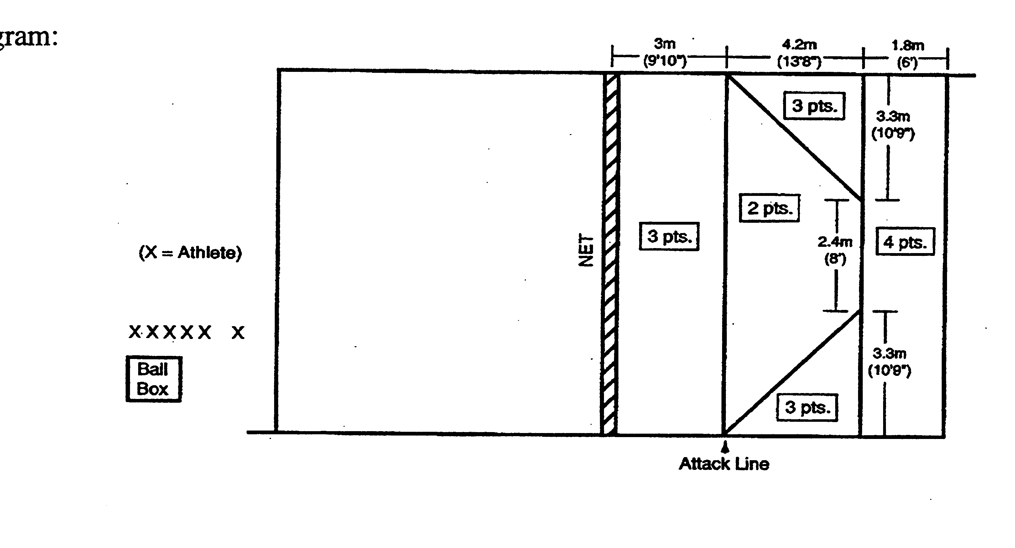

b. Set-Up: Use a regulation size court of 18m (59') long and 9m (29' 6") wide, 10 volleyballs, net (2.43m [7' 11 5/8"]) standards, antennas, measuring tape, floor tape or chalk and a ball box.

c. Test: The athlete is given 10 attempts from the service area. The athlete may serve overhead or underhand. Tape or chalk lines mark the court outlining the target areas which value from two to four points.

d. Scoring: Balls hitting on a line score the higher point value. Balls contacting the net, antennae, or landing out of bounds receive no points. The athlete's final score is determined by adding together the points awarded for each of the attempts.

  - Staging: Volunteers administer the test and are not to interfere with any athlete who is performing the test. Volunteer A will instruct the group doing this particular test while Volunteer B demonstrates the actual test. Volunteer C will toss the volleyball to the athlete who will perform. Volunteers will retrieve the volleyballs after they land and will roll them to a volunteer who is standing near the ball box. When the athlete is finished, Volunteer A will give the score to Volunteer D who is the scorekeeper. Each volunteer is to administer the test and manage their area only.

2. VSAT – Forearm Pass
a. Diagram:
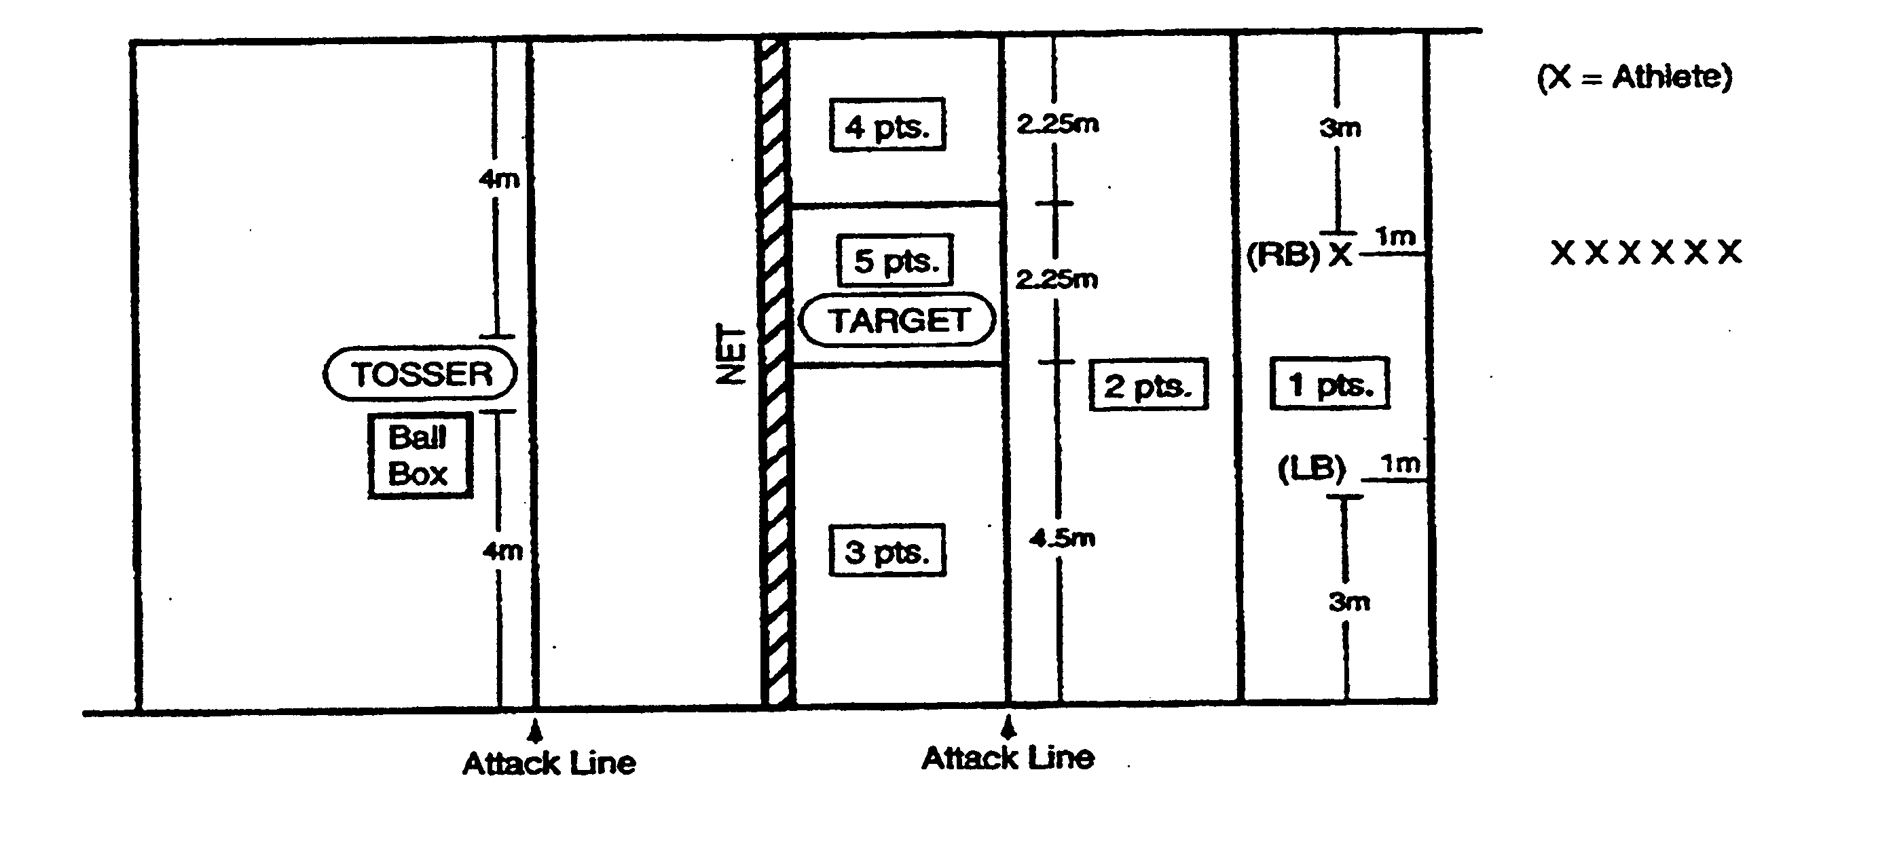

b. Set-Up: Use a regulation size court of 18m (59') long and 9m (29' 6") wide, five volleyballs, net (2.24m [7' 4 1/8"] for women and 2.43m [7' 11 5/8"] for men) standards, antennas, measuring tape, floor tape or chalk and ball box.

c. Test: The athlete receives 10 two-handed, overhead tossed balls from the TOSSER who is positioned across the net at the attack line (4.5m [14' 9"] from either sideline). The athlete is given five attempts from the right back position (3m [9' 10"] from the right sideline and 1m [3' 3 1/4"] from the baseline) and five attempts from the left back position (3m from the left sideline and 1m from the baseline). Poor tosses are repeated. The athlete passes the tossed ball toward a TARGET, a person who has their arms above their head and who is standing on the same side of the 2m (6' 6 3/4") from the net and 2m from the sideline. Target areas have values from one to five points. The peak of the arc of each passed ball must be above the height of the net.

d. Scoring: The following result is zero points: illegal contact, any ball which is passed below net height, and any ball which lands beyond the centerline. A ball hitting the line between point values will be given the higher point value. The athlete's final score is determined by adding together the points awarded for each of the 10 attempts.

e. Staging: Volunteers administer the test and are not to interfere with any athlete who is performing the test. Volunteer A will instruct the group doing this particular test while Volunteer B demonstrates the actual test. Volunteer C will toss the volleyball to the athlete who will perform. Volunteers will retrieve the volleyballs after they land and will roll them to a volunteer who is standing near the ball box. When the athlete is finished, Volunteer A will give the score to Volunteer D who is the scorekeeper. Each volunteer is to administer the test and manage their area only.

3. VSAT – Spike
a. Diagram:

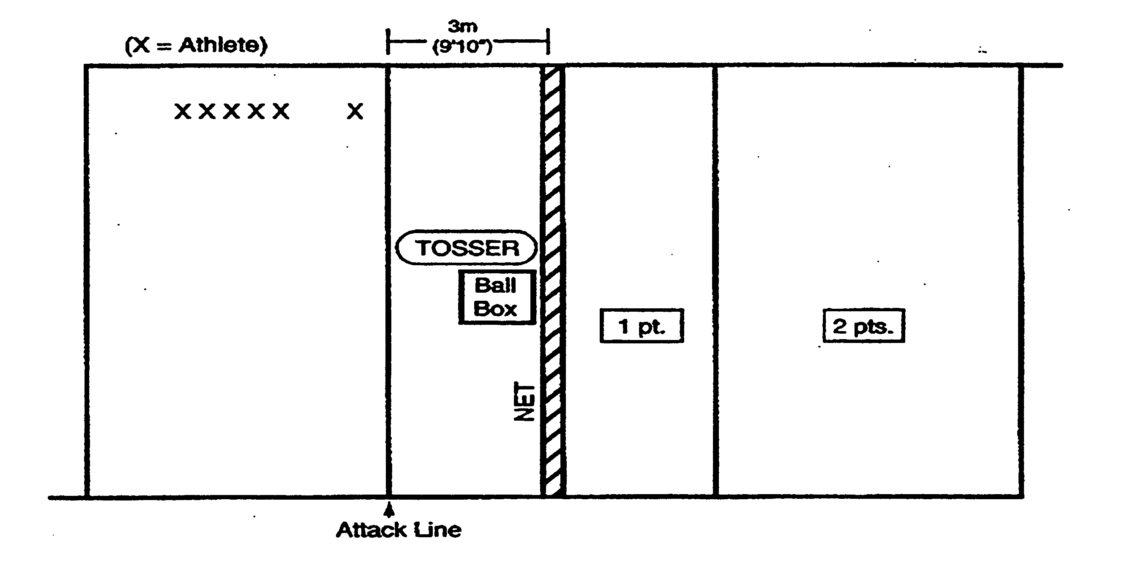

b. Set-Up: Use a regulation size court of 18m (59') long and 9m (29' 6") wide, five volleyballs, net (2.43m [7' 11 5/8"]) standards, antennas, measuring tape, floor tape or chalk and a ball box.

c. Test: Tosser will toss the ball in front of the athlete and 2m (6' 6 3/4") above the net. Tosses that are not at the proper height are repeated. The athlete stands in the court 3.05-4.57m (10-15') off the net, makes a spiking approach, and spikes the ball over the net and within the boundaries of the opponent's court. Each athlete receives 10 attempts.

d. Scoring: Athlete receives two points for each spike that lands beyond the attack line in the backcourt and one point for each spike that lands between the net and the attack line within the opponent's front court. A tip (dink) or half-speed shot is not recorded as a spike. The athlete's final score shall be the total of all 10 attempts.

  - Staging: Volunteers administer the test and are not to interfere with any athlete who is performing the test. Volunteer A will instruct the group doing this particular test while Volunteer B demonstrates the actual test. Volunteer C will toss the volleyball to the athlete who will perform. Volunteers will retrieve the volleyballs after they land and will roll them to a volunteer who is standing near the ball box. When the athlete is finished, Volunteer A will give the score to Volunteer D who is the scorekeeper. Each volunteer is to administer the test and manage their area only.

4. VSAT – Bump-Set
a. Diagram:

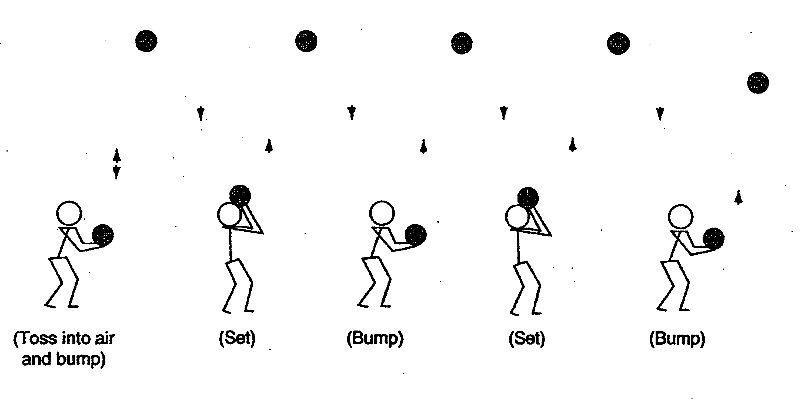

b. Set-Up: Use one-half of a volleyball court, net (minimum height of 2.24m [7' 4 1/8"]) and three volleyballs.

c. Test: The athlete alternately bumps (forearm passes) and sets the ball to him/herself without stopping. Athlete first tosses the ball into the air and then bumps the volleyball. The athlete then must move under the ball to set-bump-set-bump-set, etc. Athlete must stay within the half-court lines.

d. Scoring: Athlete is given four trials to gain his/her best score. The maximum score is 50 (25 bumps and 25 sets). Each legal hit is counted as one point as long as the ball goes above the height of the net. A particular trial is finished when the athlete sets or bumps the ball twice in a row, illegally hits the ball, goes out of the court to play the ball, or reaches a score of 50.

e. Staging: Volunteers administer the test and are not to interfere with any athlete who is performing the test. Volunteer A will instruct the group doing this particular test while Volunteer B demonstrates the actual test. Volunteer A will hand the volleyball to the athlete who will perform the skill. Other volunteers will retrieve the volleyballs after they go out of bounds. When the player is finished, Volunteer A will give the score to Volunteer C who is the scorekeeper. Each volunteer is to administer their test and manage their area only.

VOLLEYBALL SKILLS ASSESSMENT (VSAT) SCORE SHEET
NAME |  | SERVE | FOREARM PASS | SPIKE | BUMP SET | FINAL TOTAL
1
2
3
4
5
6
7
8
9
10
11
12
Sum of the top eight athletes' total scores: divided by 8 = (Team Score)
NOTE: These scores must be transferred to the State Registration rosters.

