Important: Be sure to make multiple copies of these forms for continued use.
FORMS FOR DUPLICATION
TRAINING
DVD General Orientation & Registration Form 1
Application for Sports Certification 2
Application for Sports Re-Certification/Continuing Education 3
SOWI Educational Course Reporting Form for Re-certification 4
Training Site Safety Checklist 5
FINANCE
In-Kind Contribution Receipt 6
Manual Receipt Form 7
Invoice Approval Form 8
Agency In-House Petty Cash Request Form 9
Petty Cash Ledger 10
Agency Deposit Ticket 11
Agency Deposit Ledger Template 12
Sales Tax Reporting Form 13
Money Handling Accountability 14
Expense Reimbursement Form 15
Certificate of Exemption 16
Agency to Agency Funds Transfer Form 17
Investment Options Designation Form 18
Investment Options Transfer Form 19
INSURANCE
First Report of Accident/Incident 21
Request for Certificate of Insurance 22
Contract Review Checklist 23
Insurance Needs Fundraising Event Flow Chart 24
SPORTS
Special Needs Form 25
Athlete Medical Information 26
Motor Activities Training Program 27
Sports Competition Event Grant Form 28
Filing Protests at Events 29
Disqualifications 30
SOWI Rule Change Form 31
International Rule Change Form 32
Medical Refund Request 33
FUNDRAISING
Fundraising Project Application 34
Special Event Summary 35

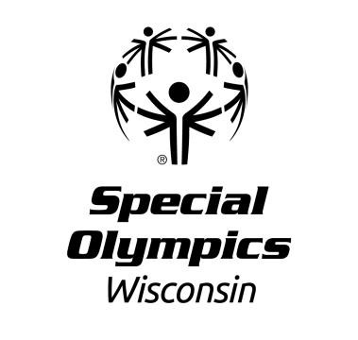
PLEASE PRINT OR TYPE CLEARLY:

SPECIAL OLYMPICS WISCONSIN
DVD ORIENTATION & REGISTRATION FORM GENERAL ORIENTATION

DATE: Region: SITE: CITY: STATE: SOWI REPRESENTATIVE: SIGNATURE:
TITLE: SOWI General Orientation DATE:

 | NAME | ADDRESS | CITY | STATE | ZIP | AGENCY
1
2
3
4
5
6
7
8
9
10
11
12
13
14

Forms for Duplication – AMH 2015 – 2016 Page 1

Agency Number:

Application for Sports Certification
One form per certification
Instructions: Please print clearly or type information below and return to the Headquarters office. List permanent mailing address and telephone number (not college address):
Name: | Email:
Address: | Home Phone:
City: | Cell Phone:
State: Zip: | Male Female
Class A Volunteer ID #(optional) : | Occupation:

If you are an SOWI athlete becoming a coach, check this box.
If your address changed since your Class A registration or last certification, please check this box.

I am a Class A registered volunteer with SOWI and have completed the required SOWI General Orientation YES / NO
I am a Class A registered volunteer with SOWI and have completed the required SOI Protective Behaviors YES / NO

I am applying for CERTIFICATION in one of the following areas:
Location of Course: Date Completed:
Sports Skills:
Coaching Special Olympic Athletes
Principles of Coaching
Coaching Unified Sports
Athlete Leadership: Coach / Official
Athlete Leadership: Global Messenger I // II
Athlete Leadership: Governance
Games Management
Official, Sport:
Other:

Coaching/Officiating experience at the high school/college levels (circle Coach or Official): Yes No

Playing experience at high school or college levels: Yes No
Sport(s) you played:

Other Information:
How many SO sports do you coach? How many sports are you certified in? Highest level of education achieved:
Do you have any relatives with an intellectual disability? Yes No If yes, relationship:

I have read the SOWI/SOI/NGB sports rules for the sport listed above, I am familiar with the SOWI Competition Guide and current rule changes, and will comply with the Certified Coach Code of Conduct.
Having satisfactorily completed all requirements, I hereby request Special Olympics certification in the area identified above.
Office use only
 | Initials | Date
BB Check
Email AM
BB Entry

Signature of Applicant Date

Signature of Agency Manager Date

Updated 05/13/2014

Forms for Duplication – AMH 2015 – 2016 Page 2
b

Process to Become a Special Olympics Wisconsin Certified Coach

- Person completing an Application for Sports Certification must be a registered Class A Volunteer, have completed the online General Orientation, and completed an SOWI Certified Training School (CTS).

- After attending a CTS, application forms must be received by the Headquarters office within one year of the date of attendance – forms received after a year will be void.
***If certification is needed for advancement to State Games, this application must be completed and submitted along with or prior to State Games registration forms.***

- All lines on the Application for Sports Certification must be filled in:
  - Agency number in the top left corner
  - Personal contact information in the boxes – please use the full name used on your Class A Volunteer form (i.e. Michelle instead of Shelly)
  - Completion status of the SOWI General Orientation must be checked YES or NO
Completion status of SOI Protective Behaviors must be checked YES or NO
  - Check the certification category applying for. If checking Sport Skills, please write the specific sport you are applying for (one sport per application)
  - Coaching/Officiating experience must be completed
  - Education and family background information must be completed

- The application must be signed by the applying coach and Agency Manager.

- It is encouraged that applicants and/or Agency Manager make a copy of the form before it is mailed to the Headquarters office.

- Once the completed form is received and approved, it is entered into the SOWI volunteer database. Coaches will receive a confirmation letter informing them of their new certification and date of expiration. All certifications expire on December 31st of the third calendar year from the date of the CTS. Before a certification expires, letters are mailed to the coach informing them of the upcoming expiration.

- If you have any questions, please contact the Director of Training & Competition at 1- 800-552-1324, ext. 5679.

- Please mail, email, or fax the application to the address below:
Special Olympics Wisconsin
Attn: Director of Training & Competition 2310 Crossroads Drive, Suite 1000
Madison, WI 53718

Email: alillethun@specialolympicswisconsin.org

Fax: 608-222-3578

Forms for Duplication – AMH 2015 – 2016 Page 2b

Agency Number:

Application for Sports Re-Certification
INSTRUCTIONS: Please print clearly or type information below and return to the Headquarters office. List permanent mailing address and telephone number (not college address).
Name

Male Female

Address

City State Zip

Home Phone Cell Phone

Email Address

Class A Volunteer ID#(optional) Occupation
If your address above is different from the address shown on your last certification application, please check the box.
I have successfully completed the required SOWI on-line Sports Assessment(s) and I am applying for re-certification in the following sport(s)

Additionally, to maintain my sports certification for SOWI, I have completed one of the following educational components:
Location of Course: Date Completed:
Sports Skills:
Coaching Special Olympic Athletes
Principles of Coaching
Coaching Unified Sports
Athlete Leadership: Coach / Official
Athlete Leadership: Global Messenger I // II
Athlete Leadership: Governance
Games Management
Official, Sport: _
USA/World Games:(date)
Other:

I have read the SOWI/SOI/NGB sports rules for the sport listed above, I am familiar with the SOWI Competition Guide and current rule changes, and will comply with the Certified Coach Code of Conduct. Having satisfactorily completed all requirements, I hereby request Special Olympics re-certification in the area identified above.

Signature of Applicant Date

Signature of Agency Manager (Optional) Date

For Office Use Only

 | Initials | Date
RE Check
SA Check
Email AM
BB Entry

Forms for Duplication – AMH 2017 – 2018 Page 3
Updated 05/13/2014

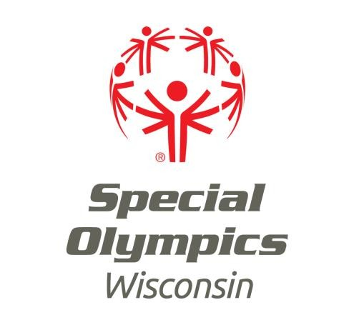

Process to Maintain Sports Certification
Follow the steps below to maintain your sports certifications. Please note that ONE educational course component will re-certify you in all sports if you also complete the online sports assessment for each sport. If you have other questions about coaching certifications, please visit the FAQs on the website under the volunteer – coaches training tab.
STEP 1: Complete one educational course component – examples include:
- Certified Training School or advanced skills course – must be sport-specific to the certification
- Principles of Coaching or Coaching Special Olympic Athletes (may only be taken one time for re- certification)
- SOWI online course, Coaching Philosophy ***Please include a copy of a completed exercise
- SONA online courses: Principles of Coaching, Coaching Special Olympics Athletes, Coaching Unified Sports ***Please include a copy of the completion certificate
- Online courses through the National Federation of State High School Association (NFHS): www.nfhs.org
- Online courses through American Sport Education Program (ASEP): www.asep.com ***Please include a copy of completion certificate from any online course.
- First Aid/ CPR Certification ***Please attach a copy of the certification card
- SOWI Conference or Health Forum (only if topics are relevant)
- Non-SOWI educational course—i.e. educational or professional in-services, conferences or seminars that pertain to working with people with disabilities, coaching, communication, conflict-resolution, etc.
***SOWI Educational Course Reporting Form must be completed after attendance and submitted with the Re-Certification Application to the Headquarters office.
STEP 2: Complete SOWI online Sports Assessment – for each sport you wish to recertify in. Sport Assessments are found on our website under the Volunteer Tab.
STEP 3: Complete the Application for Sports Re-Certification; Sign and date application and mail, fax, or email directly to the Headquarters office:
Mailing Address: Special Olympics Wisconsin
Attn: Director of Training & Competition 2310 Crossroads Drive, Suite 1000
Madison, WI 53718
Email: alillethun@specialolympicswisconsin.org Fax: 608-222-3578
***Note: The Agency Manager signature is optional; Agency Managers will receive an email notification once the application is received and processed.
***Note: Application for Sports Re-Certification must be received at the Headquarters office prior to a sports certification expiration date. If a Re-Certification Application is received after a sports expiration date, it will not be accepted.
If you have any questions pertaining to the re-certification process or non-SOWI educational course options, please contact the Director of Training & Competition at 1-800-552-1324, ext. 5679 or alillethun@specialolympicswisconsin.org

Forms for Duplication – AMH 2017 – 2018 Page 3b

Agency Number:

SOWI Educational Course Reporting Form
for Re-Certification

INSTRUCTIONS: Please print clearly or type information below and return to the Headquarters office.
To maintain my Sports Certification for SOWI, I have completed the following non-SOWI educational course:
Title:

Date: / / City:

Facilitated by:

Please explain the purpose of this course:

Please explain how the course applies to your Special Olympic coaching:
Please list three to five things you learned from the course that you will apply to your Special Olympics coaching: 1.
2.
3.
4.
5.

Having satisfactorily completed all requirements, I hereby request Special Olympics re-certification for coaching.

Applicant Name – print Date

Applicant Signature

For Office Use Only
Please mail this form with a Re-Certification Application to: Special Olympics Wisconsin
Attn: Director of Training & Competition 2310 Crossroads Drive, Suite 1000
Madison, WI 53718
Or E-mail: alillethun@specialolympicswisconsin.org Or Fax: 608-222-3578
 | Initials |  | Date
Dir. of Training & Competition
 |  | Updated 11/1/2012

Forms for Duplication – AMH 2017 – 2018 Page 4

Special Olympics Wisconsin Training Site Safety Checklist

The new Accreditation standards require that all training facilities and equipment are safe with a first aid kit, athlete emergency contacts and a phone and/or transportation available in case of an emergency.

The checklist below is not intended to cover every possible situation, but acts as a guideline for areas which could constitute injury hazards.

Acceptable?
Yes | No | Playing Surfaces – Indoor
 |  | Irregular floor surfaces (wood separations, splinters, etc.)?
 |  | Surfaces clean and free of dust, gum, wet or greasy areas, loose pieces of paper, etc.
 |  | Electrical floor plate and outlet coverings fixed properly in position?
 |  | Electrical cords away from participant area and taped securely?
 |  | All extra equipment removed?
 |  | Sufficient buffer zone between spectators?
 |  | Playing Surfaces – Outdoor
 |  | Condition of turf (pot-holes, mud, etc.)?
 |  | Puddles drained off?
 |  | Trash, glass, sharp objects, sharp-edged rocks, etc. removed off the the field?
 |  | Obvious and hidden grates well-secured?
 |  | Sufficient buffer zone between spectators?
 |  | Goal posts, goalie cages, baseball bases, etc. installed properly?
 |  | Walls
 |  | Hanging ropes or electrical lines?
 |  | Moveable equipment flush or appropriately fastened to wall?
 |  | Protruding handles or cranks?
 |  | Lighting
 |  | All areas adequately lighted?
 |  | Equipment
 |  | Personal equipment (i.e., clothing, footwear, protective equipment) appropriate to the sport?
 |  | Activity equipment (i.e., sticks, balls, goals, nets, bats, poles, whistles, cones, padding and mats) can meet the demands of the sport?
 |  | Athletes have removed jewelry?
 |  | Emergency
 |  | A first aid kit is available on site?
 |  | A copy of athletes’ Application for Participation in Special Olympics Forms with emergency contacts, insurance and medical information is on site?
 |  | Telephones within easy access?
 |  | Vehicle within easy access?

Forms for Duplication – AMH 2017 – 2018 Page 5
Updated 7/26/2012

In-Kind Contribution Receipt

In-kind contributions are services and materials donated in place of cash contributions. In-kind contributions are recorded at fair market value. Fair market value should be established on an objective and clearly measurable basis, i.e., normal rent charge for a facility, advertised costs for equipment and the posted price for food or beverage.

Date of Contribution: / /

The information below is required for internal recordkeeping. Per IRS guidelines, Special Olympics Wisconsin is prohibited from establishing monetary values for gifts of real or personal property or stating a value on donor receipts for gifts in-kind. Should you have questions, refer to www.irs.gov publications 526 & 561, and consult your tax advisor. Please retain a copy of this form for your records.

Contributor
Name:
Business/Organization:
Address:
City, State, Zip:
Phone:
Email:

Item/Service | Qty | Unit Price | Total Estimated Value  (Provided by Contributor)
 |  | $ | $
 |  | $ | $
 |  | $ | $
 |  | $ | $
 |  | GRAND TOTAL: | $

Signature of Contributor: (required)

To be completed by Special Olympics Wisconsin Representative

Purpose of Contribution:

SOWI Staff or Agency Manager:
Signature Print Name Date

In-Kind to be used by (check one):

Headquarters Region #  Fund #: 4009- Appeal: Package: Soft Cr: Event Cr: n/a  Ref: | Agency #  Account #: Reference:

Return to: Special Olympics Wisconsin (Specific return address)

Forms for Duplication – AMH 2017 – 2018 Page 6

Special Olympics Wisconsin Manual Receipt Form

Name of Payee: Agency Number:

Amount: Agency Manager Approval:

Purpose (be specific): Expense Code:

: Date Paid:

Why is original receipt missing?: Check Number:

Date of Purchase:

Name of Payee: Agency Number:

Amount: Agency Manager Approval:

Purpose (be specific): Expense Code:

: Date Paid:

Why is original receipt missing?: Check Number:

Date of Purchase:

**Please note: This form is invalid if Agency Manager has not signed for approval.

Forms for Duplication – AMH 2017– 2018 Page 7

Invoice Approval Form

Name of Payee: Agency Number:

Amount:
Agency Manager Approval Signature:

Print name

Purpose (be specific – tell who, what, where, when and why):
*Witness Approval Signature:

Print name
*MUST be signed by member of Agency Management Team who is a Class A volunteer without financial restrictions and is not a family member of the manager
Expense Code:

Date to be Paid by:

Date of Purchase:

*Please Note: This form is invalid if the Agency Manager has not signed for approval.

Forms for Duplication – AMH 2017 – 2018 Page 8

Agency In-House Petty Cash Request

Agency Number

Agency Name

Petty Cash Amount Requested $

Petty Cash for: (Please check one) Agency Fund or Special Event

If Special Event: Name of Special Event

Date Needed

Designated Class A Volunteer
This is the person who will be responsible for the petty cash and should have no financial restrictions. The check will be made out in this persons name.

Address to send check to

Approval Signature
Agency Manager Signature

Approval Signature
Class A Volunteer Signature

Forms for Duplication – AMH 2017 – 2018 Page 9

Agency number and Name:

Petty Cash Ledger

Date | Who | Amount | Where | Purpose | Expense Code

Forms for Duplication – AMH 2017 – 2018 Page 10

AGENCY DEPOSIT TICKET
Use this form to submit deposits to the Program Office.
If deposit includes taxable items such as Admissions, Auction, Concessions, Games & Entertainment or Souvenirs) attach Sales Tax Summary form.
All deposit forms can be found under “Agency Forms & Tools” on our website: www.specialolympicswisconsin.org/agency

Contact the Program Office if you need assistance logging in.
Date
Deposit Total
Total Items for Deposit
Agency #
Agency Name
Submitted by
Email Address
Attachments: | Sales Tax Summary Form Bank Deposit Receipt(s)
 | (For cash deposits made at Johnson Bank. List breakouts - Amount, Account Number & Reference in comments section below)
Comments:

Forms for Duplication – AMH 2017 – 2018 Page 11

AGENCY DEPOSIT LEDGER TEMPLATE

-Use this form to keep an in-house agency record of the deposit.

Date | First | Last | Org/Bus Name | Address | City | State | Zip | Phone | Check # | Amt | Acct # | Ref
 | Total

Forms for Duplication – AMH 2017 – 2018 Page 12

SALES TAX REPORTING FORM
- Use this form to track taxable items sold at fundraisers and special events.
- Submit completed form with deposit. Taxable items on form must match taxable items in deposit Revenue must be deposited in the month items were sold.
Sales Date:
Submitted by:
Sales Event Name:
Sales Event County:
Comments:
Item Description | Sales Tax Category:  Admissions, Auction, Concessions, Games & Entertainment or Souvenirs) | Unit Price x | Quantity Sold | = Sales Total
Total |  |  |  | $
I verify the accuracy and completeness of information listed above:

Signature Date

Forms for Duplication – AMH 2017 – 2018 Page 13

2310 Crossroads Drive, Suite 1000
Madison, WI 53718
(608) 222-1324
(800) 552-1324 (toll-free)
(608) 222-3578 (fax)

Money Handling ACCOUNTABILITY

The following procedures will occur at all SOWI fundraising events:

- At least two people will count money and both individuals will sign off on the counts in order to be held accountable.
  - These individuals will be Class A volunteers with no financial restrictions
  - These individuals will not be related to each other.
- This completed form will be forwarded to the Headquarters office with the deposit information.

Event:

Date:

Region:

Total Cash:

Total Checks:

Total Credit Card:

Total Collected:

Signature Printed Name

Signature Printed Name

Mutual Respect, Positive Attitude, Accountability, Teamwork and Dedication
Values SOWI lives by to create an environment of integrity where winning is more than coming in first.

Created by the Joseph P. Kennedy Jr. Foundation for the benefit of individuals with intellectual disabilities. Authorized and Accredited by Special Olympics, Inc.

Forms for Duplication – AMH 2017 – 2018 Page 14

Special Olympics Wisconsin, Inc Volunteer Expense Reimbursement Form

Agency Number:
Name: Address: Mileage Reimbursement:
Date | Trip/Purpose Explanation | Number of Miles | Allowance (miles x .14) | Account/ Cost Center
Totals

Other Travel Reimbursement:
Date | Trip/Purpose Explanation | Airfare | Room | Meals | Car Rental/Cab | Account/ Cost Center
Totals
- Original receipts must be attached

Miscellaneous Expense Reimbursement:
Date | Purpose Explanation | Items to be Reimbursed | Amount | Account/Cost Center
Totals
- Original receipts must be attached

Approval: Grand Total:
Agency Manager

Approval: Date:
Class A Volunteer

Forms for Duplication – AMH 2017 – 2018 Page 15

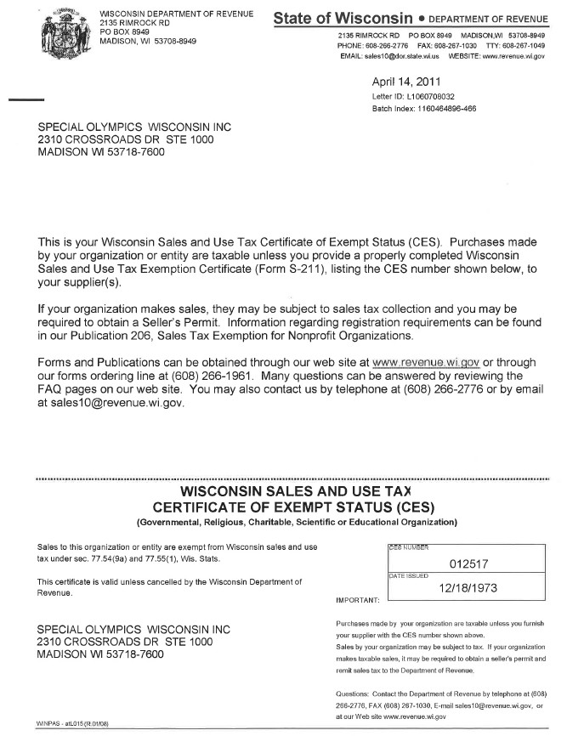

Forms for Duplication – AMH 2017 – 2018 Page 16

 |  |  | Agency to Agency Funds Transfer
Agency Holding Event
Event
Date
Reason for transfers:
By signing this form on behalf of my Agency, I authorize the transfer of funds to cover this event.
 |  |  |  |  |  |  | Class A Volunteer
Agency Number | Agency Name | Item |  | Number of Items | Cost Per Item | Total Cost | Print Name |  | Signature

Forms for Duplication – AMH 2017 – 2018 Page 17

Investment Options for Agencies Account /Amount Designation Form

Date

Agency Number

Agency Name

Deposit $ into the Special Olympics Money Market Savings Account

Deposit $ into the Special Olympics 1year Certificate of Deposit.

Agency Manager Signature & date 1

Class A volunteer Signature & date 1

Mutual Respect, Positive Attitude, Accountability, Teamwork and Dedication—Values SOWI lives by to create an environment of integrity where winning is more than coming in first.

Forms for Duplication – AMH 2017– 2018 Page 18

Investment Options for Agencies Transfer Form

Use this form when you wish to transfer money between accounts for your Agency. This transfer will be made on the 1st business day of the month.
Date

Agency Number

Agency Name

Choose One:

Transfer $ from my Agency savings account to my Agency checking account.

Transfer $ from my Agency checking account to my Agency savings account.
Agency Manager Signature 2 Class A volunteer Signature 2

Mutual Respect, Positive Attitude, Accountability, Teamwork and Dedication—Values SOWI lives by to create an environment of integrity where winning is more than coming in first.

Forms for Duplication – AMH 2017– 2018 Page 19

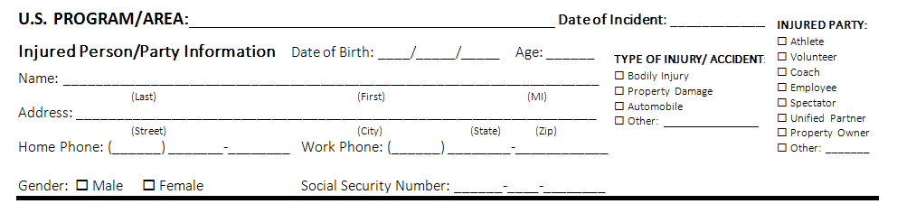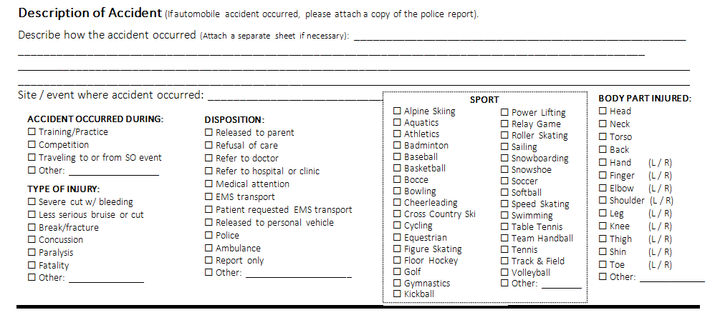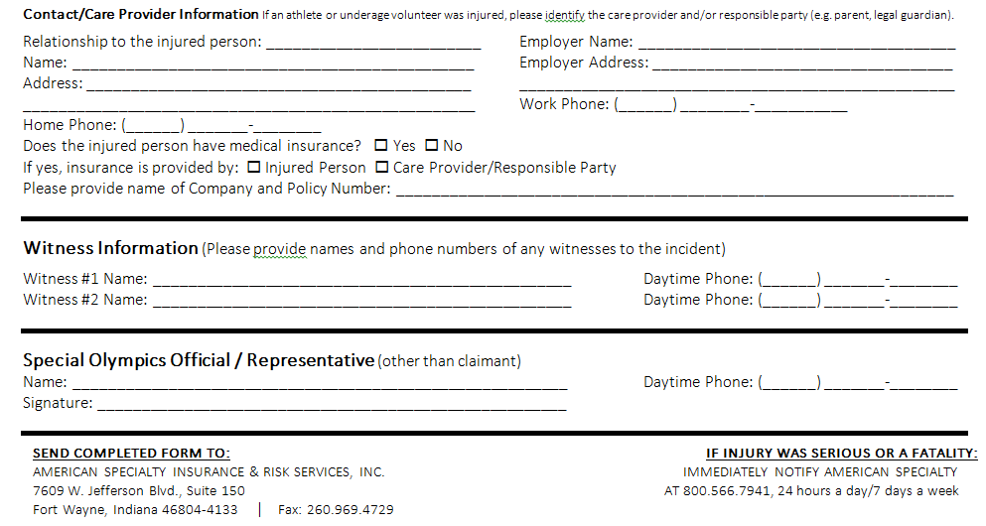

Forms for Duplication – AMH 2017 – 2018 Page 21

SPECIAL OLYMPICS
REQUEST FOR CERTIFICATE OF INSURANCE
(This form is only utilized when a facility/organization requires a certificate of insurance.)

- Date: Person Completing this Form:
- U.S. Program/Area:
- U.S. Program/Area Address:
- U.S. Program/Area Phone No: Fax E-mail
- Name of Event: Date(s) of Event:
- Site or Location of Event:
- Is Event a Fundraising Activity? YES NO If the event is a Fundraising Activity, please provide answers to the following:
  - Will the event last more than 7 consecutive days? YES NO
  - Will more than 5,000 spectators/participants be in attendance of the event? YES NO
  - Are participants required to sign a Release of Liability Waiver? YES NO
Please attach any pertinent information regarding fundraising activities (brochure, advertisement, specific details)

Note: If the event involves any of the following, please contact Jina Doyle at jdoyle@amerspec.com or (260)673-1127 immediately, as the policy either specifically EXCLUDES coverage for these events or requires the U.S. Program to meet certain underwriting requirements. Coverage is not provided for the following activities unless approved in advance by the Insurer.

- Alcohol
- Rock Climbing Walls
- Aircraft (other than a Plane Pull)
- Animals (other than Equestrian practices/competitions)
- Firearms
- Fundraising Events lasting more than 7 consecutive days
- Inflatable Devices
- Mechanical Rides
- Golf Ball Drops
- Fireworks
- Rodeos
- Fundraising Events with more than 5,000 people (including spectators and participants) in attendance

8) Is Event Exclusively for Special Olympics Athletes? | YES | NO
9) Is Event Sponsored by a Special Olympics Program? | YES | NO
10) Is the Event Conducted by a Special Olympics Program? | YES | NO
11) Is Alcohol Being Served at the Event? | YES | NO
If so, please provide additional details (such as alcohol is included in ticket price, cash bar, donated):
- Certificate Holder (entity requiring certificate):
- Does the Certificate Holder require Additional Insured status*? YES NO
  - If so, please outline the requested Additional Insured wording:
  - If so, please outline the Additional Insured’s role in the event (such as sponsor, location of event, etc.

- Certificate Holder Contact Person:
- Certificate Holder Address:
- Certificate Holder Phone No.: Fax: E-mail:
*ADDITIONAL INSURED STATUS SHOULD BE CHECKED ONLY IF IT IS A REQUIREMENT OF THE CERTIFICATE HOLDER.

- Are you required to enter into an agreement/contract/permit with another party relative to the above-referenced event that contains assumption of liability, indemnification, or hold harmless language? YES NO
If so, please send a copy of the contract with the Certificate Request Form.
Original Certificate should be sent to: Certificate Holder U.S. Program
SEND TO:
ATTN: RENE WATERSON E-MAIL: rwaterson@amerspec.com AMERICAN SPECIALTY INSURANCE & RISK SERVICES, INC.
P.O. BOX 309
ROANOKE, IN 46783-0309 TELEPHONE: (800) 245-2744 FAX: (260) 672-8835

Forms for Duplication – AMH 2017 – 2018 Page 22

Purpose of Checklist

Special Olympics Wisconsin Contract Review Checklist

The following checklist is provided as a tool to help Special Olympics U.S. Programs when determining whether to sign a contract/agreement with a venue or facility. This checklist focuses on risk management issues and applies primarily to facility or venue use agreements/contracts. Although some of the same principles may apply, this checklist is not intended to be used for contracts such as hotel agreements, sponsorship agreements, long-term building leases, etc. A U.S. Program should always follow its own protocol relative to the contract review process and should work with legal counsel and insurance representatives (American Specialty or local broker) as appropriate.

Using the Checklist
If the answer to any of the questions below is "no," separate action is recommended prior to signing. Also, please utilize the Event Flowchart to help identify any additional steps that may need to be taken relative to insurance.

Yes No | Do you have a complete, legible copy of the contract?
Yes No | Are all parties listed by their formal legal names?
Yes No | Are the effective dates and times of the agreement accurately stated?
Yes No | Are the individuals to sign the agreement authorized representatives of each party?
Yes No | Is the indemnification and hold harmless provision "acceptable"?  Acceptable:  - Other party indemnifies and holds Program harmless for losses, and Program doesn't indemnify or hold other party harmless; or  - Each party is responsible for its own negligence - mutual indemnification and hold harmless; or  - Program indemnifies and holds other party harmless but not for losses arising from other party's negligence (or other party's sole or gross negligence). This is acceptable although above options are preferable.  Not Acceptable  - Program indemnifies other party and holds them harmless for any and all losses (including those arising from other party's own negligence), and other party doesn't indemnify or hold Program harmless.
Yes No | Does the Program carry the insurance coverage required in the contract?
Yes No | Is the additional insured requirement consistent with the indemnification and hold harmless provision?  For example:  - If there is mutual hold harmless and indemnification, the parties should name each other as additional insured.  - If the Program must hold harmless and indemnify the other party for losses arising out of the Program's negligence only, then the Program should be required to name the other entity as an additional insured only with respect to losses arising out of the Program's negligence.
Yes No | Are the cancellation requirements acceptable (for example, they do not place an undue financial burden on the Program if the Program needs to cancel)?

Forms for Duplication – AMH 2017– 2018 Page 22

Insurance Needs Fundraising Event Flowchart

Is Special Olympics directly involved in organizing and conducting the fundraiser? Note: if the answer to this is “no,” then the event is being conducted by a third party and Special Olympics’ only role is to be the beneficiary of the funds raised at the event
No Yes
Does the event pose an acceptable activity that you would want to have associated with Special Olympics?
Yes No

No
Does the event include any of the following?
- Aircraft (including Golf Ball Drops, but not Plane Pulls)
- Firearms
- Events lasting more than 7 consecutive days
- Events with greater than 5,000 people at any one time (other than Polar Plunges)
- Rodeos
- Rock Climbing Walls
- Inflatable devices
- Mechanical Carnival Rides
- Construction activities
- Political Rallies
- Fireworks
- Animals
- Organized in conjunction with another entity
- Alcohol
- Skydiving
- Hot air balloons
- Water related activities
- Snowmobiles
- Motorcycles

No
Decline offer
Provide other entity with correct method for describing Special Olympics as beneficiary and ensure there is a process to approve in advance all uses of the Program’s name and logo. Comply with any state or local laws regarding fundraising. Be aware that SOCIP does not cover the other organization or its volunteers and notify the other organization about this. No certificates of insurance will be provided for this event.

Are you required to enter into a facility use agreement and/or do you require a certificate of insurance?
Yes No
Yes

Conduct a safe and productive event!
Request that the other entity name Special Olympics as an additional insured to their liability policy since our name will be associated with the event
Select appropriate option

Contact Jina Doyle immediately (800-245-2744), as the SOCIP general liability policy EXCLUDES COVERAGE FOR the aforementioned activities that are in bold unless certain underwriting requirements are met and the other activities (not in bold) may require additional consideration or risk management recommendations.
NOTE: If the event is organized in conjunction with another entity, American Specialty will request information on responsibilities of each party and will suggest the following:
- Execute a contract with other organization outlining each party’s responsibilities, including mutual hold harmless/indemnification wording, and requiring other party to name SOI and your Program as additional insured.
- Obtain additional insured certificate from other organization.
- Send contract/certificate to American Specialty for review.

Contract and Certificate
Contract Only (with hold harmless or indemnification language)
- Follow Program's contract review procedures.
- Negotiate favorable hold harmless and indemnification language. Use American Specialty for assistance as needed.
- Submit contract to local Legal Counsel and American Specialty for review.
- It is recommended that the contract is signed only after approval by Legal Counsel and American Specialty.
Certificate Only
- Complete Request for Certificate of Insurance form.
- Submit request form to American Specialty.
Contract Only with no hold harmless or indemnification language
- Submit to local Legal Counsel for approval from a legal perspective
- Sign contract. Use American Specialty for assistance as needed.
  - Follow Program's contract review procedures.
  - Negotiate favorable hold harmless and indemnification language.
  - Complete Request for Certificate of Insurance form.
  - Submit contract and request form to American Specialty.
  - Sign contract only after approval by American Specialty.

Conduct a safe and productive event!

Forms for Duplication – AMH 2017– 2018 Page 23

SPECIAL NEEDS ATHLETE FORM

Completed Special Needs Forms can be copied, but must be submitted at the registration deadline for ALL levels of competition.

Coaches who have athletes with special needs (i.e. communication limitation, hearing or visual impairment, special equipment adaptations or behavioral needs) can relay important information to the event volunteer as to how to best work with the athlete. In some cases, a coach may be allowed to be in the competition area for consultation with the volunteer(s) working with the athlete. It is important in this situation for the coach to introduce the athlete to the volunteer(s) and advise the volunteer(s) on how to work with the athlete. The coach will not be allowed to remain in competition area. Special needs forms are intended to be an aid for the volunteer in working with the athlete and are not to be used for performance-related instructions or coaching tips.

If you have a “Special Needs” athlete please complete the following form (one per athlete). If necessary, this information will be included on the event card. If you do not complete this form, it may be more difficult to accommodate the “Special Needs” for your athlete.

Athlete Name:
Agency Number and Name:
Coach Name:

REQUEST 1:1 Volunteer needed in competition area
- Must obtain prior approval from Event Director (not all requests can be approved).
- Check reason(s) and provide a brief explanation below

REQUEST 1:1 State Games Housing Chaperone (non-competition related) – provide a brief explanation below
1:1 Class A Chaperone Name: (must match your Coach/Chaperone Roster)

General Volunteer assistance at the venue – check reason(s) or provide a brief explanation below

General Special Needs: (check all that apply)
 | Guide to/from event/start |  | Non Verbal
 | Behavior issues |  | Hearing Impaired
 | Wanders |  | Visually Impaired
 | Unsteady on feet |  | Seizures
 | Special Equipment – explain below: |  | Medical condition that may require the administration or consumption of medication, food or liquids during competition. – provide a brief explanation below.
 | Other – explain below:

Explanation: (Please be as brief as possible):

Forms for Duplication – AMH 2017– 2018 Page 24

ATHLETE MEDICAL INFORMATION

Agency: Coach: Athlete Name: Sex: M F Address:
Coronary Artery Disease Pacemaker
Bleeding/Clotting Disorder Sickle Cell Anemia
Stroke Dementia
Hearing Impaired Vision Impaired Other/Details

Date of Birth: S.S. #: Doctor: Phone: Specialty Doctor: Phone: Specialty
EMERGENCY CONTACTS
- Name: Phone: Address:
- Name: Phone: Address: Able to Make Own Medical Decisions Y / N

MEDICAL INSURANCE
Company Name: Policy Number: Company Name: Policy Number:

ALLERGIES (Please describe reaction)
No known allergies Environmental
Insect Stings Latex Aspirin
Ibuprofen Tylenol Penicillin
Other Allergies Reaction Description(s)

MEDICATIONS

GENERAL HEALTH INFORMATION
Name | Dose | Frequency | Indication

Pain Tolerance: Low Normal High Last Tetanus Shot
If applicable:
Last Influenza Shot Last Pneumococcal Shot MEDICAL DATA AS OF: Month Year

MEDICAL HISTORY (Check all that exist) No known medical conditions
Asthma Seizure Disorder
Diabetes Hypertension

Forms for Duplication – AMH 2017– 2018 Page 25

Athlete Medical Information Instructions
The following are additional questions/clarification to assist you in providing the most accurate and relevant medical information to Special Olympics-WI coaches and medical staff, in addition to emergency medical personnel, if needed. Please feel to provide sensitive information via other methods.

Emergency Contact
Is the athlete able to make own medical decisions?
If no, please indicate on form and list who is able to make such decisions, i.e. guardian/Power of Attorney for Healthcare, as Emergency Contact #1.

General Health Information: Please see below and the back of this sheet for a list of questions.

Medical History: Please check/list all current medical problems, major surgery/illness, and medical conditions that may alter evaluation or treatment. In addition, please see below and back side of this sheet for questions about certain conditions.

Allergies: Please check/list any allergies (medication, food, latex, other). Include type of reaction [Anaphylactic (trouble breathing, throat swelling), rash, GI problems, other]

Medications: Please list all medications, vitamins and supplements taken. In addition, list any recent medication changes and medication side effects that need to be watched for (sun sensitivity, dehydration, etc) in the General Health Information Section. Also, please include if and what over-the-counter medications the athlete may have for minor pain, etc.
Heart/Lung Conditions
  - Does the athlete have a heart or lung condition that places them at higher risk of illness or injury? [determined by a physician]
  - Does the athlete have high blood pressure, irregular heart rhythm, heart murmur, or bleeding problems?
    - Do they take medication?

Gastrointestinal Conditions
  - Does the athlete have chronic over/under eating, heartburn, constipation, diarrhea, or abdominal pain?
    - Medication?
    - Treatment (foods to avoid, etc)

Headaches/Migraines
  - Does the athlete often get headaches/migraines?
  - How severe are they?
    - Complications: vomiting, visual changes, etc?
  - How long do they last?
  - What treatment is most effective?

Urinary Conditions
  - Does the athlete have frequent urinary tract/bladder infections?
    - Signs/Symptoms?
    - Frequency of infections?
    - Usual Medication (antibiotic prescribed by a physician)

General Medical Information Questions: Please indicate answers in the General Health Information or Medical History Sections (only need to provide information if answer is different than “normal”)

General Information
  - Is the athlete unable to answer the following?
    - Date, Place, Date of Birth
  - Does the athlete have any significant weakness, paralysis, decreased sensation, deformity, spasticity, or rigidity?
  - Does the athlete have any hearing, eye or vision problems, especially unequal pupils?
    - Any communicative disabilities?
  - Does the athlete have any chronic skin conditions?
  - Any “missed” immunizations?
  - Any significant family history (heart disease, diabetes, cancer)?
  - Any medical dietary restrictions? Please indicate reason for restriction.

Female Specific
  - Does the athlete have heavy menstrual bleeding or cramping?
  - Does she know her menstrual cycle?
  - Any possibility of pregnancy?

Behavioral/Disability Conditions
  - Does the athlete need assistance with personal cares, meals, daily activities, etc.?
  - Any behavioral problems or psychiatric diagnoses?
    - Triggers? Interventions? Medications?

Specific Medical Condition Questions Seizures
  - Are they true seizures, pseudo-seizures, fake/behavioral seizures?
  - Please describe in detail a typical seizure, including frequency, duration, body movements, staring, post- seizure recovery behavior/duration, reasons for going to the emergency department.
  - Recent medication changes?

Diabetes
  - Do they have a glucometer? Are they able to check their own blood sugar? How often do they check their blood sugar levels?
  - Is there any medication that needs to be adjusted for missed meals or increased activity? If so, which medications and how?
  - Do they often have episodes of low blood sugar?

Asthma
  - Do they have asthma?
  - Triggers?
  - How severe is their asthma?
    - How often do they have an attack?
    - How severe is their attack?
    - Recent ED visits/hospitalizations?
History of ICU visits/intubations?

Forms for Duplication – AMH 2017 – 2018 Page 26b

MOTOR ACTIVITIES TRAINING PROGRAM (MATP) SANCTION FORM
This form must be completely filled out and submitted to the Program office at least eight weeks prior to the scheduled training day activity. Challenge award ribbons will be mailed out to MATP programs two weeks prior to the event.

PLEASE PRINT OR TYPE

MATP Coordinator:

Phone: Daytime: Evening:

E-mail Address:

Agency:

Address:

City: State: Zip:

Estimated number of MATP Special Olympics athletes participating:

Estimated coach-to-athlete ratio:

Training Dates:

Training Site: (Location) (City)

Training Day Activity Site (if different):
(Location) (City)

Mail eight weeks prior to training day activity to:

Special Olympics Wisconsin 2310 Crossroads Dr. Ste. 1000
Madison, WI 53718
Attn: Director of Training and Competition

Forms for Duplication – AMH 2017 – 2018 Page 27

MOTOR ACTIVITIES TRAINING PROGRAM (MATP)

The Special Olympics Motor Activities Training Program (MATP) is designed for persons with the most severe handicaps who do not yet possess the physical and/or behavioral skills necessary to participate in Official Special Olympics Sports. The program provides a comprehensive motor activity and recreation training curriculum for these participants that can be administered by a variety of trainers (e.g., physical educators, re-creators, and therapists). In addition, direct care workers, parents, and volunteers will find the MATP helpful in developing appropriate motor programs for individuals with severe handicaps.

The Motor Activities Training Program emphasizes training and participation rather than competition. The MATP utilizes goals, short term objectives, task analyzed activities, assessments, and teaching suggestions for individualizing motor activity instruction so that persons with severe handicaps can participate in appropriate recreation activities geared to their ability levels. These activities can be conducted in schools and large residential facilities, as well as in community-based settings.

GOALS AND OBJECTIVES
LONG – TERM GOAL – The long-term goal is a global statement about what you feel your participant can accomplish in a one-or two-year time period.

The participant will demonstrate motor and sensory-motor skills, appropriate behavior, and an understanding of the skills and rules of the Motor Activities Training Program that will enable him/her to successfully take part in training day activities and official Special Olympics sports.

SHORT TERM OBJECTIVES – Choose two to four short-term objectives that you feel your participant can achieve in an 8- to 16-week training program:

- Given demonstration and practice, the participant will warm-up properly (with assistance as needed) before performing motor activities.

- Given demonstration and practice, the participant will demonstrate an awareness of visual, auditory, and/or tactile stimulation.

- Given demonstration and practice, the participant will successfully perform mobility activities.

- Given demonstration and practice, the participant will successfully perform dexterity activities.

- Given demonstration and practice, the participant will successfully perform striking activities.

- Given demonstration and practice, the participant will successfully perform kicking activities.

- Given demonstration and practice, the participant will successfully perform activities using a manual wheelchair.

- Given demonstration and practice, the participant will successfully perform activities using an electric wheelchair (when appropriate).

- Given demonstration and practice, the participant will successfully take part in aquatics activities.

- Given demonstration and practice, the participant will successfully participate in age-appropriate modified group games and sports.

- Given that the participant has successfully completed a six-to-eight-week training program, the participant will take part in a training day.

- Based on the participant's motor skills, he/she will take part in official Special Olympics sports, training day activities, and/or community- based sport and recreation activities.

The MATP is being introduced to Special Olympics Wisconsin (SOWI) programs through a series of coaches certified training schools. SOWI strongly encourages each program interested in developing the MATP to have at least one of their coaches become certified as a MATP coach. Coaches’ certification is not a requirement, but will greatly aid in delivering a quality MATP program to the Special Olympics athletes.

To assist programs with implementing the MATP program, SOWI will provide cost-free challenge award ribbons. Special Olympics athletes who complete an eight-week training session and participate in training day activities are eligible to receive a ribbon. In order to be sanctioned as an official SOWI MATP program and receive the challenge award ribbons, a program must submit a sanction form at least eight weeks prior to the scheduled training day. (NOTE: This is to insure an adequate supply of challenge award ribbons are on hand.)
Questions on MATP can be answered by contacting the SOWI Sports Department at (800) 222-1324 or visit www@specialolympicswisconsin.org.
Forms for Duplication – AMH 2017 – 2018 Page 27b

SPORTS COMPETITION EVENT GRANT FORM

INTENT:
To support registered Agencies of Special Olympics Wisconsin in their efforts to organize, promote and implement multi-Agency team competitions in sports offered by Special Olympics Wisconsin.

APPLICATIONS:
Grants for competitions may be used only to offset officials' fees, facility costs, equipment rental fees, and crucial event costs. (NOTE: Awards, travel, mementos, etc. are not applicable costs for grant expenditures.)

REQUIREMENTS:
- Grant applications are to be submitted by a representative of a registered (current) SOWI Agency.
- The competition (i.e., tournament, meet, etc.) must involve a minimum of three different SOWI Agencies.
- The competitive event in question must utilize properly certified/current sport officials and follow applicable SOI, SOWI and National Governing Body rules.
- SOI and SOWI awards policies must be followed.
- Each grant application must be accompanied by a rough draft of the organizational aspects of the event schedule in question; i.e., competition format, numbers of teams to be involved, any committee structure, site, date, etc.
- Each grant must include a budget listing overall tournament expenses and how grant money will be allocated, plus overall expenses.
- A grant application must be received at your SOWI Area office a minimum of thirty (30) days in advance of the date of the event.

RESTRICTIONS:
- A registered SOWI Agency may receive more than one grant per program year and multiple grant applications are encouraged.
- A maximum award of $400.00 is available for each grant application.
- Grants are not applicable toward SOWI-sponsored area, district, regional or state events.
- Grants will be issued on a "first-come, first-served" basis; forms received will be date-stamped, awarded by merit and in order of receipt. (When grant money is no longer available, agencies will be notified.)

REVIEW PROCESS/AWARDS:
All grants will be reviewed as soon as possible after receipt and any follow-up contacts will be made at that time. Final notification of grant approval and amounts to be received will be as expeditious as possible to facilitate the applicant's event planning processes.

Forms for Duplication – AMH 2017– 2018 Page 28

SPORTS COMPETITION EVENT GRANT FORM
EVENT TITLE: DATE: SPORT: FACILITY TO BE USED: APPLICANT’S NAME: ADDRESS: CITY: STATE: ZIP: WORK PHONE: ( )
HOME PHONE: ( )
AGENCY NUMBER: AGENCY NAME: GRANT AMOUNT DESIRED:
(Maximum is $400.00)

INTENT OF GRANT FUNDS (Briefly describe how money will be used):

SIGNATURE OF APPLICANT: DATE:

Please attach the event budget and submit to the Area office 30 days in advance of the event.
Approved:
Denied:
OFFICE USE ONLY
Amount Awarded:
Date:

Forms for Duplication – AMH 2017– 2018 Page 28b

FILING PROTESTS AT EVENTS
- Protests to the games rules committee may only be made concerning games presentation, structure and conduct.
- Protests to the sports rules committee may only be made concerning competition of athletes within a venue, where within that competition, rulings are determined in regard to the fairness and equity of the competition.
- All protests must be initiated prior to the presentation of awards.
- Protests must be presented to the head official of the event immediately in an oral fashion so that the event officials may be made aware of the appeal.
- The head official may rule on appeals immediately, but if the response of the head official does not resolve the protest, a formal protest may follow.
- All formal protests must be submitted within a half hour of the event in question.
- All protests must be made on this official form.
8. All protests will be brought to the attention of the sports rules committee for final resolution. The decision of this committee shall be final and binding unless this committee concludes that the protest concerns games presentation, structure and/or conduct, at which time the committee will refer the protest to the games rules committee.

PROTEST FORM
Date: Time Submitted: Sport: Event: Age Group: Division (Heat): Athlete or Team Name: Identification Number: Agency Number: Reason For Protest:

Signature of Sport Head Coach:
***********************************************************************************************
DECISION BY SPORTS RULES COMMITTEE
Protest Approved: Protest Denied:

Signed:
Date: Time:

Forms for Duplication – AMH 2017 – 2018 Page 29

DISQUALIFICATIONS
All Special Olympics Wisconsin (SOWI) athletes who do not conform to the rules and regulations of the sport in which they are competing are subject to disqualification. All disqualifications are made by the judge or official responsible for each event. All disqualified athletes will be officially signaled as such at the time of the infraction. The judge or official declaring the disqualification will fill out an official event disqualification report and submit it to the sports rules committee.

Below is a sample of the form the official will use for disqualifications. Please note that aquatics uses a separate form.

OFFICIAL EVENT DISQUALIFICATION REPORT
1. Event: 2. Division: 3. Lane:
- Athlete Number:
- Athlete Name:
- Reason For Disqualification:

Judge’s Signature:
- Time: Date:

Forms for Duplication – AMH 2017 – 2018 Page 30

SPECIAL OLYMPICS WISCONSIN PROPOSED RULE CHANGE FORM
Name of Sport: Date of Submission:

Mail form to: Special Olympics Wisconsin Sports Rules
2310 Crossroads Dr
Suite 1000
Madison, WI 53718 Submit by: May 1st Annually
Or, e-mail to: kbergmann@specialolympicswisconsin.org

Recomended change to: General Sports Rules/ Policies Sport Specific Rules/ Policies
Sport:
Official Special Olympics Sports Rules Version you are reading from for this change:

Rule Reference (i.e. General Information Section – Competition Guide, or Athletics — Section E-Rules of Competition, 1.b.)

Page Number

Rule as it Reads:

Recommendation: (Check the Box of the action proposed)
Delete rule Add new rule Change to read as follows:

Reason for Proposed Rule Change:

Person Submitting Rule Change:

Address:

Agency:

Daytime Telephone Number: E-mail Address:

……………………………………………………………………………………………………………………………………………………….
For Rules Committee Use Only

APPROVE AS PROPOSED

NOT APPROVED

REFER TO SPORTS RESOURCE TEAM FOR ADDITIONAL INFORMATION

APPROVED WITH THE FOLLOWING REVISIONS:

Forms for Duplication – AMH 2017 – 2018 Page 31

INTERNATIONAL RULE CHANGE FORM
Name of Sport Date of Submission:

Mail form to: Sports Rules Advisory Committee (SRAC)
c/o Sports Department Special Olympics Inc. 1133 19th Street, NW Washington, DC 20036 USA

Or, e-mail to: sportsrules@specialolympics.org

Official Special Olympics Sports Rules version you are reading from for this change:

Rule reference (i.e. Cycling — Section E-Rules of Competition, 1.b.)

Please see attached file. New events, etc are outlined in red.

Page number

Rule as it reads:

Recommendation: (Check the box of the action proposed) Delete rule
Add new rule
Change to read as follows:

Reason for proposed rule change:

Addition of developmental events for athletes who do not have the ability to compete in novice, intermediate and advanced leves. In addition, additional rules for addition of a snowboard cross event.

Has this rule change been field tested/ utilized? If so, where and with what results?

Affiliated Special Olympics Program:

Rule change submitted on behalf of Special Olympics Program: YES
NO

Person submitting rule change:

Address:

Daytime telephone number:

…………………………………………………………………………………………………………………………………………

For Rules Committee Use Only

APPROVE AS PROPOSED

NOT APPROVED

REFER TO SPORTS RESOURCE TEAM FOR ADDITIONAL INFORMATION

Forms for Duplication – AMH 2017 – 2018 Page 32

MEDICAL REFUND REQUEST
Directions:
  - Complete this form and attach a doctor’s explanation.
  - Mail To:
SPECIAL OLYMPICS WISCONSIN 2310 CROSSROADS DRIVE, SUITE 1000
MADISON, WI 53718

The request and doctor’s report must be received within 10 days of the conclusion of the event. Late or incomplete requests will be denied. If approved, the refund check will be mailed in the Agency’s name to the Agency manager.

Athlete Name: Agency Number: Agency Name: Event:

A medical refund is requested for the athlete above. The doctor’s explanation is attached.

Contact Name: Signed: Date:

SPECIAL OLYMPICS WISCONSIN – USE ONLY

Approved: $
Denied: Coding Expense:

Signed:
Chief Operating Officer (COO)

Check Number: Date:

Forms for Duplication – AMH 2017– 2018 Page 33

Special Olympics Wisconsin FUNDRAISING PROJECT APPLICATION

Name of
project:
This project is on behalf of:
Local Agency
Individuals or Organizations involved in project:
Project
date(s):
Give a brief description of the project:
Is a raffle being held in conjunction with this event? No Yes*
*If yes, see raffle requirements in Fund Raising section of the Agency Manager Handbook
Will the Special Olympics name or logo be used?
No | Yes | (If yes, attach a sample of material(s))
Estimated dollars to be raised (gross income): |  |  |  | $
Estimated expenses: |  |  |  | $
Estimated dollars to local Agency: |  |  |  | $
Submitted by:
Name |  |  |  | Title
Mailing Address |  |  |  | Telephone
Email Address
RETURN TO REGIONAL OFFICE 30-60 DAYS PRIOR TO EVENT
Approved:
Regional Director of Development |  |  |  | Date

Forms for Duplication – AMH 2017– 2018 Page 34

Special Event Summary

Agency/Region: Agency/Region Staff Time Involved: Event: Number of Volunteers: Prior to Event Dates: Day of Event
List of Corporate Sponsors
Name Cash Actuals In-Kind Actuals
1.
2.
3.
4.

Expenditures |  | Income
 | Cash Actuals | Source (pledges, auction, etc.) | In-Kind | Cash Actuals
Prizes |  | 1.
Event Food |  | 2.
Printing/Photography |  | 3.
Facilities |  | 4.
Appreciation/Hospitality |  | 5.
Administrative (Insurance) (Permits) (Postage) |  | 6.
 |  | 7.
 |  | 8.
 |  | 9.
Incentives/Souvenirs |  | 10.
 |  | 11.
 |  | 12.
Sales Tax Miscellaneous |  | 13.
 |  | 14.
Total Expense | $ | Total Income | $ | $
Net (Income - Expense) | $
Cost to Raise a Dollar : (Total Expense ÷Total Income)
Intangible assets of doing this event:

Forms for Duplication – AMH 2017– 2018 Page 35

