FOOTBALL (SOCCER) TEAM SKILLS ASSESSMENT TEST (FSAT)
These skills are designed to help determine a preliminary idea as to the ability level of the athletes. They should
be used as a teaching method for basic skills used during a game setting.

a. Football (Soccer) Team Skills Assessment Test – Dribbling
1) Set-up: 12m dribbling slalom: five cones (minimum 18" high), 2m apart, staggered 0.5m from central line, and three to five balls at the start line.

2) Test: (Time: one minute) Player dribbles through slalom as quickly as possible, rounding all cones. Player leaves ball over the finish line (ball must be stopped) and sprints back to the start. If there is time remaining, player starts with second ball and repeats. Player continues to repeat until one minute has elapsed to signify the end of the test. A whistle will be blown when one minute has elapsed to signify the end of the test.

- Scoring: Player scores five points for each cone passed (to the outside) (i.e. 25 points per successful run). Cones that are knocked down do not count.

b. Football (Soccer) Team Skills Assessment Test – Control and Pass

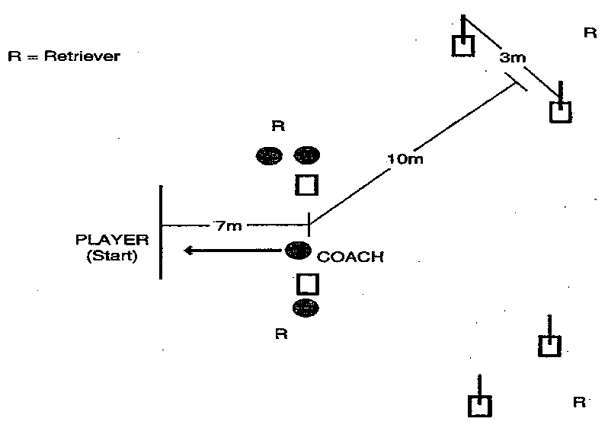

1) Set Up: Two cones to form a "passing gate" 5m wide, 7m from the starting line, two passing "target gates" (cones and 1m flags if possible) as shown, and four to eight soccer balls. (If balls are in short supply, use four balls but have an efficient retrieval system for returning the balls to the coach.)

2) Test: (Time: one minute) Coach rolls the ball at a moderate pace to the waiting player. The player may wait on the line or move towards the ball once it has been rolled.
Player controls the ball and dribbles through the passing gate. Coach alternately calls and physically indicates "left" or "right" to designate target. Ball 1: Right / Ball 2: Left / Ball 3: Right, etc. Players can dribble as close as they like before passing the ball through the target. The coach will roll the next ball as soon as the player returns to the starting line. At one minute, a whistle will be blown to signify the end of the test.

3) Scoring: Player scores 10 points for each successful pass through a target gate. A ball that hits the cone and goes through will count.

c. Football (Soccer) Team Skills Assessment Test – Shooting
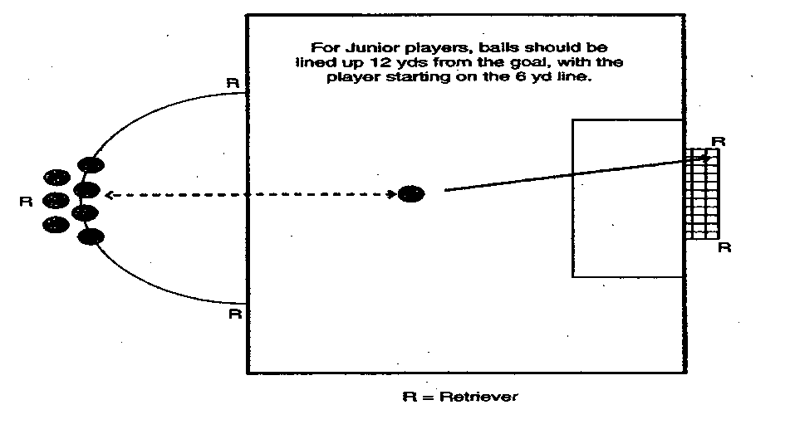
1) Set Up: Penalty area and full-size goal, with nets, on a regulation field and four to eight balls at the top of the penalty arc. (If balls are in short supply, the test can be run with four to five balls with a good retrieval and return system.)

2) Test: Player starts at the penalty spot, runs to the first ball, dribbles into the penalty area and shoots, attempting to shoot the ball in the air into the goal. Players can shoot from whatever distance they choose once they are inside the penalty area. As soon as the player has shot, he/she returns and repeats with another ball. A whistle will be blown after one minute to signify the end of the test.

3) Scoring: Player scores 10 points for each shot traveling from foot to goal in the air and five points for each shot that touches the ground before entering the goal.

FINAL FSAT SCORING: Total the final score for each of the three FSAT skill tests for each player. This score should then be entered on the roster entry form for district and State competition.

FOOTBALL (SOCCER) SKILLS ASSESSMENT (FSAT) SCORE SHEET

NAME |  | DRIBBLING | CONTROL & PASS | SHOOTING | FINAL TOTAL
1
2
3
4
5
6
7
8
9
10
Sum of the top seven athletes’ total scores: divided by 7 = (Team Score)
NOTE: These scores must be transferred to the district and State registration roster

