Athlete Health Leader Workshop

Register for Special Olympics Wisconsin’s Athlete Health Leader Workshop:

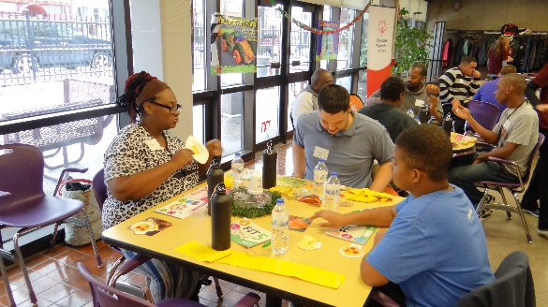
- Saturday, October 13 from 10:00 am – 3:00pm

- Ascend Services
2818 Meadow Lane, Manitowoc WI

- Return Registration by October 1, 2018

- Contact Jeanne Hrovat, Director of Special Projects jhrovat@specialolympicswisconsin.org
608-219-0492 (cell)
Learning about Fit Five curriculum
- Trainers will include:
  - Steve Woodard, SOWI Athlete Health Leader
  - Roy Pirrung, SOWI coach, mentor and Hall of Fame runner
  - Deb Moore-Gruenloh, SOWI coach and certified clinician
  - Amy Pingel, Fitness Enthusiast

“As part of athlete health leadership we learn about self-advocacy. Through wellness and fitness we gain self-esteem, self-determination, self-control, self-motivation, self-worth and self-discipline. We learn to be and feel like our best self.” – SOWI athlete Martha Hill
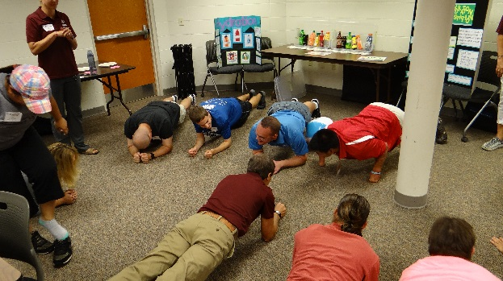

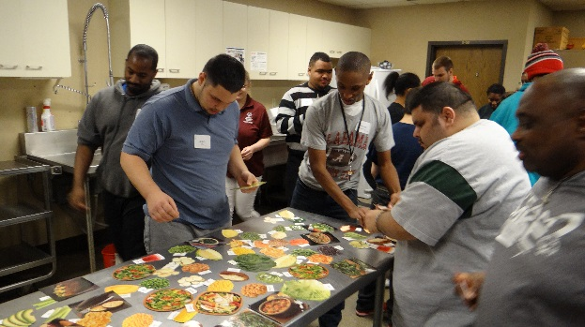
Nutrition Education
Physical Wellness Activities

Athlete Leadership - Athlete Health Leader Workshop

Goal of Workshop: To provide athletes with the additional skills necessary to become an effective ambassador for the health and wellness movement in Special Olympics; understand more about self-health and wellness; become an advocate for health and wellness programs.
Athlete Health Leader Job Description –one year commitment.
- Participate in a five hour training on Special Olympics’ health strategy and the role athlete leaders have.
- Promote health and fitness on Special Olympics teams and at events.
- Teach others about Special Olympics and Fit 5 curriculum including Nutrition, Hydration and Physical Wellness education.
- Continue working with SOWI staff as needed.
- Be a self-advocate around health.
- Collect health stories from Special Olympics athletes.
- Advocate for peers, teammates and others with intellectual disabilities and help them become health leaders as well.
- Be a role model to other SO athletes by leading a healthy lifestyle.
- Utilize social media to promote good health.
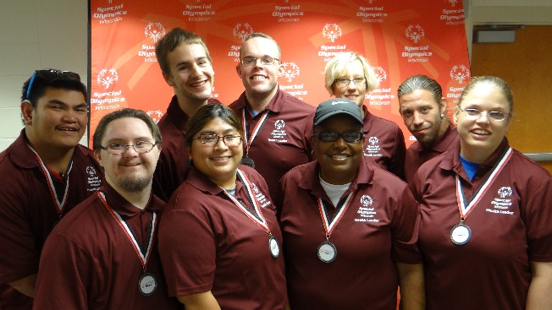
10. Mentor and collaborate with other athlete leaders and share ideas about how to improve as an athlete leader in health.
Current Athlete Health Leaders

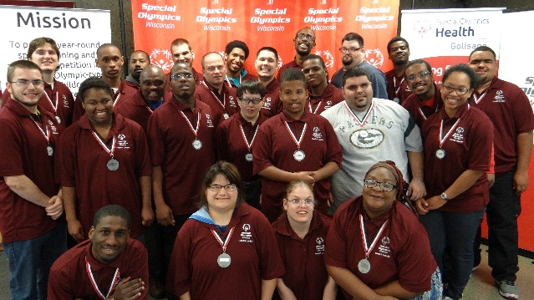
Team Milwaukee Dec 2017
Portage July 2017

Athlete Health Leader Workshop

DATE: Saturday, October 13, 2018 Registration deadline is Monday, October 1, 2018.
TIME: 10:00 am – 3:00 pm (We will have sub sandwiches for lunch)
LOCATION: Ascend Services, 2818 Meadow Lane, Manitowoc, WI
CLINICIANS: Deb Moore-Gruenloh, Roy Pirrung, Amy Pingel and Steve Woodard
DRESS: Dress to participate!
Jeanne Hrovat, Director of Special Projects, Special Olympics Wisconsin,
2310 Crossroads Drive, Ste 1000, Madison, WI 53718, jhrovat@specialolympicswisconsin.org
800-552-1324 ext 5666 (or “0” for operator) Fax – 608-222-3578
ATHLETE NAME: AGENCY:
ADDRESS: CITY & ZIP:
DAY (Cell) PHONE: EMAIL:
Shirt Size: _____ Dietary Needs: _____________________________________________________
Do you require any disability-related accommodations, such as written materials in an alternate format, sign-language interpreter, wheelchair accessibility, etc.? ☐ Yes ☐ No
If yes, please describe:______________________________________________
Are you on Facebook and will you join a SOWI Athlete Leadership Group?___yes_____no
Are you a registered Class A Volunteer for Special Olympics Wisconsin? ☐ YES ☐ NO
Have you completed the on-line General Orientation Training? ☐ YES ☐ NO
MENTOR NAME: AGENCY:
ADDRESS: CITY & ZIP:
DAY (Cell) PHONE: _______________ EMAIL: __________________________
Are you a registered Class A Volunteer for Special Olympics Wisconsin? ☐ YES ☐ NO
Have you completed the on-line General Orientation Training? ☐ YES ☐ NO
To be successful Athlete Health Leader, please communicate your wishes to your Agency Manager.
_________________________________________ ________________________________________ ______________ Agency Manager Printed Name Agency Manager signature Date of Signature

