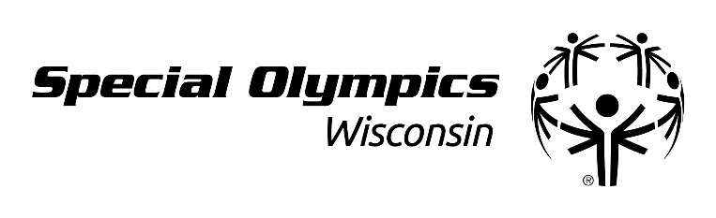
CLASS B VOLUNTEER REGISTRATION
State Summer Games, June 6-8, Stevens Point

VOLUNTEER INFORMATION
First Name: |  |  |  | Last Name:
Date of Birth (mm/dd/yyyy): |  |  |  | ☐ Female ☐ Male ☐ Other
Address:
City: |  |  |  | State: | Zip Code:
Phone: |  |  |  | Email:
Race/Ethnicity (Optional):
☐ American Indian/Alaskan Native  ☐ Black or African American  ☐ White |  |  | ☐ Asian ☐ Two or More Races  ☐ Native Hawaiian or Other Pacific Islander  ☐ Hispanic or Latino (specific origin group:_________________________)
Language(s) (Optional): Mark all that apply
☐ English | ☐ Spanish | ☐ Other (please list): _________________________
EMERGENCY CONTACT INFORMATION
Name:
Phone:
Relationship:
PARENT / GUARDIAN INFORMATION (required if minor or otherwise has a legal guardian)
Name:
Relationship:
☐ Same Contact Information as Volunteer
Address:
City: |  |  |  | State: | Postal Code:
Phone: |  |  |  | E-mail:
GROUP OR AFFILIATION (check all that apply)
☐ I am volunteering as a member of a club, volunteer organization or civic group.
Name of group: _____________________________________________
☐ I am a student. Name of school currently attending: ____________________________________________

Type of School (circle one): Elementary Middle School High School Military Academy College/University Other

CLASS B VOLUNTEER REGISTRATION

I agree to the following:
- Ability to Participate. I am physically able to take part in Special Olympics activities. I know there is a risk of injury.
- Likeness Release. I give permission to Special Olympics, Inc., Special Olympics games/local organizing committees, and Special Olympics accredited Programs (collectively “Special Olympics”) and Special Olympics partners and sponsors to use my likeness, photo, video, name, voice, words, and biographical information to promote Special Olympics, raise funds for Special Olympics, and acknowledge partners’ and sponsors’ support for Special Olympics.
- Emergency Care. If I am unable, or my guardian is unavailable, to consent or make medical decisions in an emergency, I authorize Special Olympics to seek medical care on my behalf.
- Personal Information. I understand that Special Olympics will be collecting my personal information as part of my participation, including my name, image, address, telephone number, health information, and other personally identifying and health related information I provide to Special Olympics (“personal information”).
- I agree and consent to Special Olympics:
  - using my personal information in order to: make sure I am eligible and can participate safely; run trainings and events; share competition results (including on the Web and in news media); provide health treatment if I participate in a health program; analyze data for the purposes of improving programming and identifying and responding to the needs of Special Olympics participants; perform computer operations, quality assurance, testing, and other related activities; and provide event-related services.
  - using my personal information for communications and marketing purposes, including direct digital marketing through email, text message, and social media.
  - sharing my personal information with (i) medical professionals in an emergency, and (ii) government authorities for any purpose necessary to protect public safety, respond to government requests, and report information as required by law.
- I have the right to ask to see my personal information or to be informed about the personal information that is processed about me. I have the right to ask to correct and delete my personal information, and to restrict the processing of my personal information if it is inconsistent with this consent.
- Privacy Policy. Personal information may be used and shared consistent with this form and as further explained in the Special Olympics privacy policy at www.SpecialOlympics.org/Privacy-Policy.aspx.
- Waiver and Liability Release. I understand the risks involved with participation in Special Olympics activities. I fully accept and assume all such risks and all responsibility for losses, costs, and damages I may incur as a result of my participation. I hereby release and agree not to sue any Special Olympics organization, its directors, agents, volunteers, and employees, and other participants (“Releasees”) related to any liabilities, claims, or losses on my account caused or alleged to be caused in whole or in part by the Releasees. I further agree that if, despite this release, I, or anyone on my behalf, makes a claim against any of the Releasees, I will indemnify and hold harmless each of the Releasees from any such liabilities, claims, or losses as the result of such claim. I agree that if any part of this form is held to be invalid, the other parts shall continue in full force and effect.

Name:
VOLUNTEER SIGNATURE (required for adult with capacity to sign legal documents)
I have read and understand this form. If I have questions, I will ask. By signing, I agree to this form.
Volunteer Signature: | Date:
PARENT / GUARDIAN SIGNATURE (required for participant who is a minor or lacks capacity to sign legal documents)
I am a parent or guardian of the participant. I have read and understand this form and have explained the contents to the participant as appropriate. By signing, I agree to this form on my own behalf and on behalf of the participant.
Parent / Guardian Signature: | Date:
Printed Name: | Relationship:

