**CORNHOLE**

###### GENERAL RULES

The Official Special Olympics Sports Rules shall govern all Special Olympics Cornhole competition. Special Olympics has created these rules based on the American Cornhole Association (ACA) rules, which shall be employed except when they are in conflict with the Official Special Olympics Sports Rules.

**OFFICIAL EVENTS OFFERED**

1. Team Competition (doubles two-person)
2. Unified Sports® Team (two-person)

**SECTION A – GENERAL RULES**

1. The Game
   1. Equipment – Cornhole is played with 8 bags, four each of colors, and a cornhole platform.
      1. Each Cornhole platform shall be a 48-inches x 24-inches rectangle made of half inch plywood or plastic.
      2. The hole in the platform shall be six (6) inches in diameter and be centered nine (9) inches from the top and 12 inches from each side of the edges.
      3. The front of the platform shall be from 2-1/2 inches from bottom to top and be at near a 90-degree angle to the deck face.
      4. The back of the platform shall be 12 inches from ground to the highest point of the deck at a 90-degree angle to the deck face.
      5. The platform surface shall allow corn bags to slide but is not so slippery that it allows the bags to slide back down the platform.
      6. 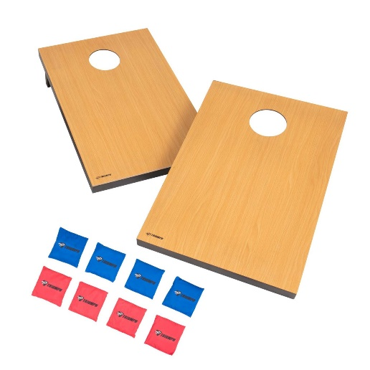The corn bags shall be made from two (2) fabric squares with a quarter inch double stitched seam on all four (4) sides. The corn bags should be made from 12-ounce per square yard canvas and may be any color. Each bag shall be filled with approximately two (2) cups of corn feed and finished bags should be a minimum of 6-inches x 6-inches square and weigh between 14 and 16 ounces.
   2. Court- 3’ wide x 4’ long pitchers box will be marked. One at each end of the 21’ court, measured end zone to end zone of each box. The platform will be stationed on the foul line, front of the pitchers box. Any level surface inside or outside is acceptable.

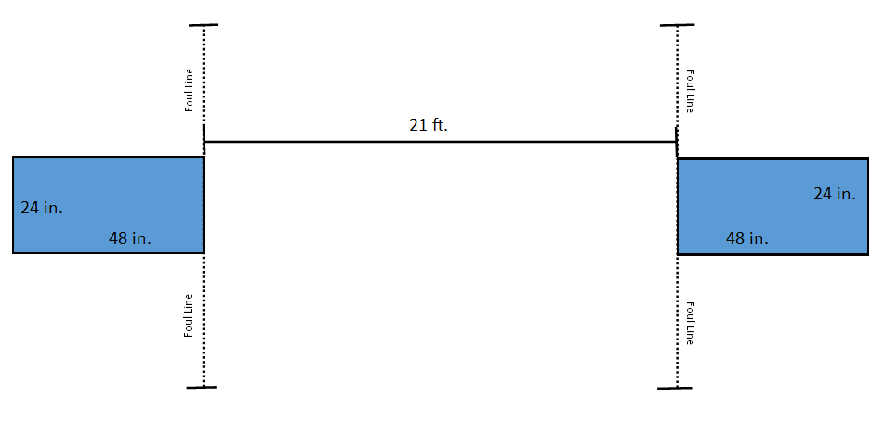

Team B Pitchers Box

Team B Pitchers Box

Team A Pitchers Box

Team A Pitchers Box

* 1. Sequence of Play – A coin toss by the referee will determine which team starts, side, and choice of bag color. Player one from team A will toss 1 bag, followed by one player from team B tossing 1 bag. The players will continue to alternate throws until all 8 bags have been tossed.
     1. An athlete may deliver the bag from either the left or right pitchers box (see court layout above); but, in any one (1) inning, all bags must be delivered from the same side of the pitcher’s box.
     2. An athlete shall pitch the entire tournament with the same hand or arm, except in the case of a medical emergency.
     3. An athlete must use an under hand toss.
     4. Teammates will throw straight across to each other.(see above)
     5. The team who scored the most points in the preceding half-inning shall pitch first in the next half-inning. If neither pitcher scores, the team who pitched second (last) in the preceding half-inning shall pitch first in the next half-inning.
     6. The games will played to 21 or 30 minutes.
  2. Scoring – Value Of The Corn Bag
     1. Corn Bag In-The-Hole: Either from being thrown through the hole in the platform or by being knocked in by another player, has a value of three (3) points.
     2. Corn Bag on the platform: A corn bag that is not in-the-hole but lands with any portion of the bag (without touching the ground) resting on the platform has a value of one (1) point.
     3. Points will not “cancel out”. Each team may score during the inning, points are added consecutively as made.
     4. The first player/team to reach (or exceed) 21 points at the conclusion (end) of an inning is the winner.
  3. Ties at the End of Inning – In the event that both teams have the same score, the team that went first will go first for the next half-inning.
  4. Ties at the end of Tournament Play - if two or more teams are tied in the final place standings at the end of competition, ties will be broken by the following tie break procedure:
     1. Head to Head
     2. Point Differential
     3. Total Points Scored

1. Substitutions
   1. Official Notification - Officials must be notified of line up changes prior to scheduled game time or it will result in forfeiture of the match.
   2. Rotation of the Players between games
      1. Rotation of Players – Team rosters may have up to three athletes per team with two athletes playing per game. Player rotation (changing the team lineup) may take place between games and any two of the three athletes on the roster may be used for the line up for any games played.
      2. Limitations – Once a player has registered for one team during the tournament, the player may not play for any other team during that tournament.
2. Timeouts and Delays of Game
   1. Circumstances
      1. Timeout – The official may grant a timeout whenever the circumstances explained appear to be of sufficient validity to do so. The timeout will be limited to 10 minutes.
      2. Intentional Delay of Game – If, in the opinion of the official, the game is intentionally delayed without sufficient or valid reason, the official must give a warning. If play is not resumed immediately, the delaying team will forfeit the match.
3. Specific Fouls
   1. Foul line Fouls –any part of the player’s foot or any apparatus used by an athlete such as a wheelchair, crutches, cane, etc., may not cross the foul line, front of the pitchers box. A referee, as a result of witnessing the foul, must call all fouls. The penalty for a player committing the foul will be to declare the specific shoe being thrown dead. The referee will remove the just-released ring from the court.
   2. If a corn bag touches the ground before coming to rest on the platform, it is a foul and must be removed from the Corn Toss platform prior to the continuation of play.
4. Player Behavior
   1. Whenever possible, a player should move out of the box when an opponent is playing.
   2. Unsportsmanlike Conduct - Players shall act in a sportsmanlike manner at all times. Any act which is deemed as poor sportsmanship such as insulting language, gestures, actions, or words which produce ill-will, if flagrant, may result in disqualification.

### SECTION B – DIVISIONING

1. All teams will play as coed open teams.
2. Teams will be divisioned according to coaches’ input and scores of at least two games played versus other Special Olympics Cornhole teams

**SECTION C – UNIFORMS**

1. Proper Attire – Players will dress in a manner which will serve to bring credit to them and the sport of Cornhole. Players not wearing proper attire will not be allowed to participate. All players on a team shall wear uniform tops that are identical in color, trim and style. Players may wear shorts, warm-up pants, or pants and need to be identical in color. (Player bottoms may vary between shorts and long pants on the same team.) No denim jeans or cut offs!
2. Footwear – Players will not be permitted to wear shoes which may damage or disrupt the court surface. Shoes must cover participant’s toes. Players will not be permitted to compete wearing sandals, flip flops or no shoes.

**SECTION D – UNIFIED COMPETITION**

1. Each Unified Sports team event shall consist of one athlete and one partner for all rounds.
2. Each game shall follow the same rules as above.

**CORNHOLE ASSESSMENT TEST (CHAT)**

* 1. The CHAT is designed specifically to measure the basic skills necessary to participate in the sport of corn hole i.e., the delivery of the bag, while focusing on a target.
  2. All athletes to be entered in Cornhole competition must have completed the entire CHAT (along with his or her team members) in order to be eligible for competition.
  3. Caution: You should administer the CHAT only after athletes have become familiar with the scoring area and procedures and shortly before your district entries are due.

**CORNHOLE ASSESSMENT TEST (CHAT)**

**SCORE SHEET**

**Agency Number:** **Agency Name:**

**Team Name:**

1. Each player being tested will stand behind the throwing line 21 feet from the board and will deliver four bags. The tosses will be totaled up.
2. They will have three consecutive trials. The bags will then be disinfected before the next athlete.
3. All three trials will be added.
4. The two top players scores will be added together and then divided by 2. This is the team average.

|  |  |  |  |  |  |
| --- | --- | --- | --- | --- | --- |
| **TEAM MEMBERS** | | **TRIALS**  **21’ from the boards** | | | **\*TOTAL OF 3 scores from each trial** |
| **1** | **2** | **3** |
| **1** |  |  |  |  |  |
| **2** |  |  |  |  |  |
| **3** |  |  |  |  |  |

**CHAT TEAM AVERAGE** When all three trials are completed, each of the three scores shall be added together into one cumulative score.

The sum of the top two (best) athlete totals for all of the three trials =       divided by 2 =

**Transfer this total to state registrations.** If you have more than one team, rank your teams, with the best team having 1 the next 2 and so forth.