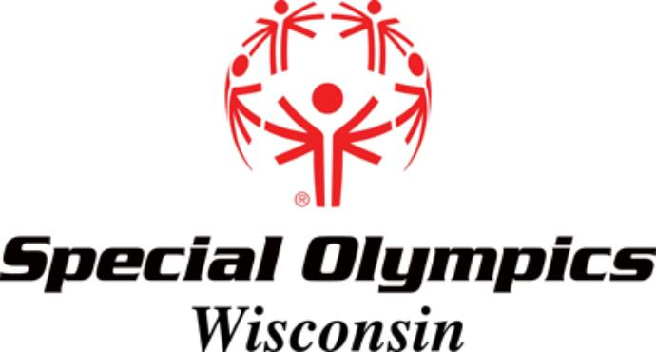
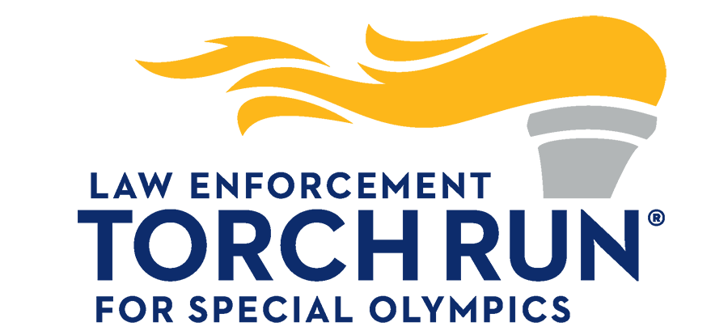
RELEASE AND WAIVER OF LIABILITY, ASSUMPTION OF RISK,
INDEMNITY AGREEMENT, AND PARENTAL CONSENT
(Do not sign without reading)

In exchange for permission for me and/or my minor child to participate in the Special Olympics Wisconsin Law Enforcement Torch Run® 2021 Be Strong and Rebel Ride activity in _______________, WI, I represent that:

*I UNDERSTAND THE NATURE OF THE ACTIVITY. I am participating in the Activity by:
5K Walk 5K Run Bench Press Truck Pull Deadlift Strongman Motorcycle riding
(circle above as applicable)

*I UNDERSTAND THAT THE ACTIVITY INVOLVES risks of serious bodily injury, including permanent disability, paralysis and death, which may be caused by my own actions, or inactions, those of other Activity participants, the conditions in which the Activity takes place, or the negligence of the RELEASEES named below; and that there may be other risks either not known to me or not readily foreseeable at this time. I understand that the activity will be conducted over public roads and facilities open to the public during the Activity and upon which traffic hazards are to be expected. I acknowledge that if I and/or my minor child believe event conditions are unsafe, I and/or my minor child will immediately discontinue participation in the Activity.

*I CONSENT TO THE PARTICIPATION OF MY MINOR CHILD. (This applies only if my minor child's name is shown below as a participant.)

*I FULLY ACCEPT AND ASSUME ALL SUCH RISKS AND ALL RESPONSIBILITY for losses, costs, and damages I and/or my minor child incur as a result of my and/or my minor child’s participation in the Activity.

*I HEREBY RELEASE, DISCHARGE AND PROMISE NOT TO SUE Special Olympics Wisconsin, Special Olympics, Inc., its respective administrators, directors, agents, officers, volunteers, and employees, other participants, any sponsors, advertisers, and, if applicable, owners and landlords of premises on which the Activity takes place (each considered one of the "RELEASEES" herein), from all liability, claims, demands, losses, or damages that I and/or my minor child suffer which are caused or alleged to be caused in whole or in part by the negligence (but not reckless or intentional conduct) of the RELEASEES or otherwise, including negligent rescue operations.

*I WILL INDEMNIFY, SAVE AND HOLD HARMLESS each RELEASEE from any loss, liability, damage, or cost which any may incur, if, despite this release and waiver of liability, and assumption of risk, I or anyone on my and/or my minor child's behalf, makes a claim against any RELEASEE.

* I HAVE CONSIDERED that if this waiver of liability was not as broad as it is, the cost for my participation in the event would be considerably higher, and as I do not wish to pay a considerably higher cost, I waive the right to bargain for different waiver of liability terms.

*I HAVE READ THIS RELEASE AND WAIVER OF LIABILITY, ASSUMPTION OF RISK, INDEMNITY AGREEMENT, AND PARENTAL CONSENT (collectively "Agreement"), UNDERSTAND THESE TERMS AND UNDERSTAND THAT I HAVE GIVEN UP SUBSTANTIAL RIGHTS BY SIGNING THIS AGREEMENT, and have signed it freely and without any inducement or assurance of any nature. No Releasee or person on behalf of any Releasee has told me anything that is inconsistent with or contrary to the terms of this Agreement. I understand that, in reliance upon my signature on this form, voluntarily given, I may be permitted to participate in the Activity noted above. I intend it be a complete and unconditional release of all liability to the greatest extent allowed by law. If any portion of this Agreement is held to be invalid, the balance shall continue in full force and effect.

*DO NOT SIGN this Release and Waiver form unless you understand and accept the terms stated above.

Print name of Participant here Date

Signature of Participant (if age 18 or over) Signature of Custodial Parent/Legal Guardian
For self and any other parent/guardian (If participant under age 18)
Witness to Above Signature

