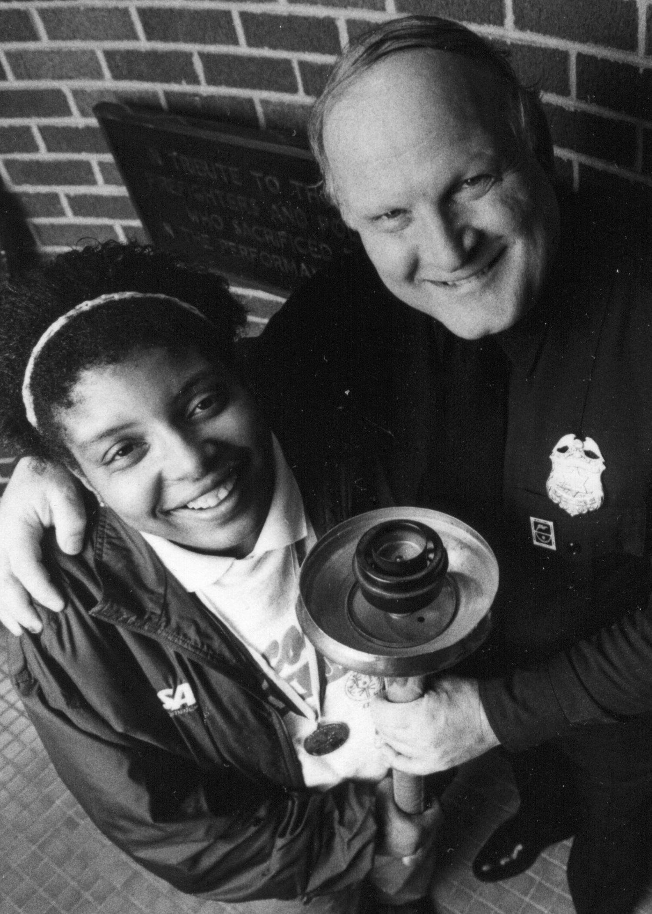



**Wisconsin LETR Dale Brunner Hall of Fame Award**

**Wisconsin Law Enforcement Torch Run®**

**Dale Brunner Hall of Fame Award**

**In 1986, when the Torch Run began in Wisconsin, Dale Brunner ignited a spark among law enforcement officers to spread awareness of individuals with intellectual disabilities and raise money to support the athletes of Special Olympics Wisconsin. That eternal flame burns with even more vigor today.**

**Dale was a US Army Veteran with the 82nd Airborne “Red Devils”, a Milwaukee Police Officer for 31 years and served as a Washington County Sheriff’s Deputy for 10 years. His passion for his family and children lead to his devotion to charitable work. Most notably, Dale served as the first director of the Law Enforcement Torch Run® (LETR) for Special Olympics Wisconsin from 1986 through 1999. In February 1992, Dale was one of 11 inaugural inductees into the International Richard LaMunyon Hall of Fame, named for the founder of the Torch Run, the Hall of Fame is the most prestigious award given in the Torch Run community.**

**In 1999, the inaugural Wisconsin Law Enforcement Torch Run Dale Brunner Hall of Fame award was presented. This award was created to recognize Wisconsin’s outstanding law enforcement volunteers and Special Olympics staff who have significantly contributed to the statewide success of Wisconsin’s Torch Run. It is an honor bestowed on those participants who have gone above and beyond the normal call of duty in their efforts to enhance the Torch Run and its support of Special Olympics Wisconsin’s mission.**

**On August 12, 2014, sadly Dale passed away after a very courageous battle with brain cancer. A Final Leg run was held in his honor.**

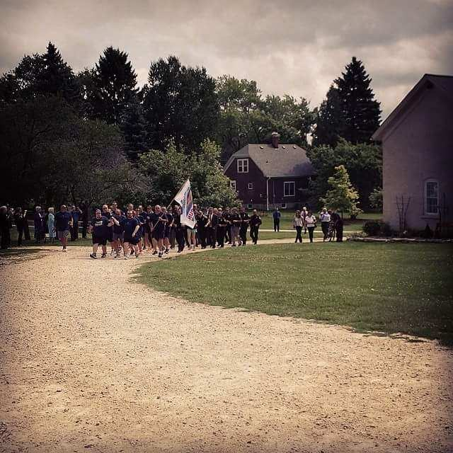



**WISCONSIN LAW ENFORCEMENT TORCH RUN®**

**DALE BRUNNER HALL OF FAME AWARD**

***The Wisconsin Law Enforcement Torch Run® Dale Brunner Hall of Fame Award recognizes outstanding individuals who have significantly contributed to the statewide success of the Law Enforcement Torch Run® for Special Olympics Wisconsin.***

**2018 Inductee**

Brian Zimmerman, Racine County Sheriff’s Office

**2017 Inductee**

Niki (Nichelle) Nelson, Waukesha Police Department

**2016 Inductees**

Richard Dressler, Retired, Grant County Sheriff’s Office

Matthew Harper, Winneconne Police Department & SOWI

Sara Knapp, Shiocton Police Department

Dean Wendlandt, Sheboygan Police Department

**2015 Inductees**

Andrew J. Dewitt, Wisconsin Rapids Police Department

David Kleinhans, Department of Justice

Robert Roeske, Retired, Rothschild Police Department

**2014 Inductees**

Lori Casper, Dane County Sheriff’s Office

Jeff Smith, Retired, West Allis Police Department

**2013 Inductees**

Dennis Alldridge, Special Olympics Wisconsin

Mark Mauthe, Menasha Police Department

Jennifer Merlin, Department of Corrections

**2012 Inductees**

Mark Horstmann, Verona Police Department

Brian Krueger, Sheboygan Police Department

**2011 Inductees**

Dave Gerber, Walworth County Sheriff’s Office

Kathy Schult, Milwaukee Police Department

**2010 Inductees**

Jenny LeBelle, Winnebago County Sheriff’s Office

Gene Rousseau, Retired, Brown County Sheriff’s Office

Michael Teem, Honorary Induction, Raleigh (NC) Police Dept.

**2009 Inductee**

Daryl Pries, Cadott Police Department

**2008 Inductees**

Dan Brauer, Glendale Police Department

Tammy Kubisiak, Grand Rapids Police Department

**2007 Inductees**

Peggy Frank, City of Eau Claire

Chief Richard LaMunyon, Founder of the Law Enforcement Torch Run®, with Dale Brunner, Wisconsin’s first LETR Director

Mark Moan, Jackson County Sheriff’s Office

**2006 Inductees**

Richard LaMunyon, Honorary Induction, Founder Law Enforcement Torch Run® for Special Olympics, Kansas

John Graham, Retired, Fond du Lac Police Department

Colleen Handrick, Globe University

Ray Merlin, Kenosha County Sheriff’s Office

Anthony Zblewski, Stevens Point Police Department

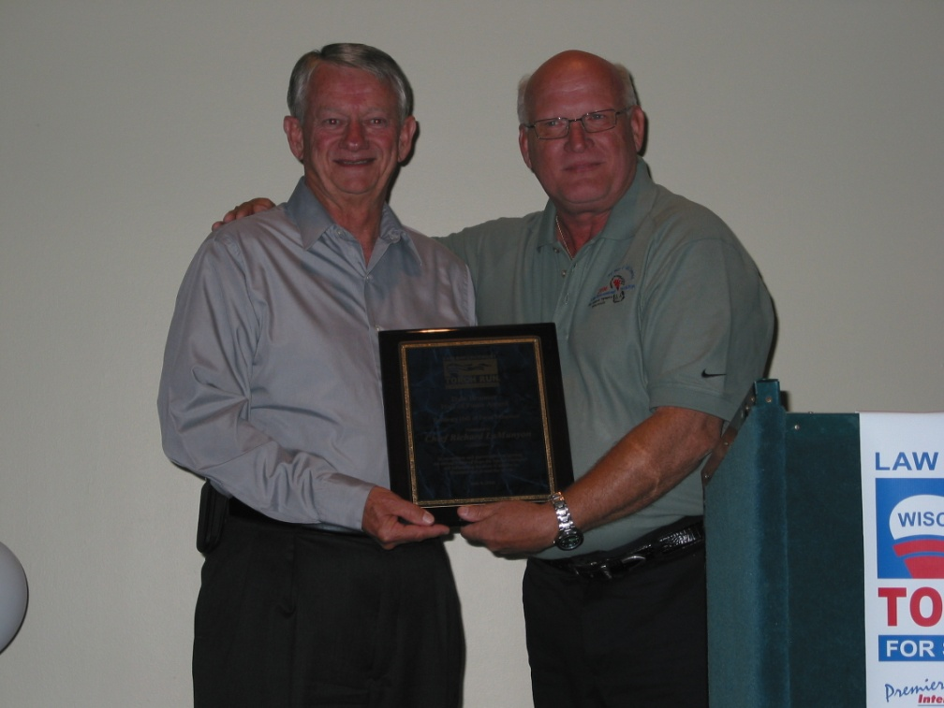**2005 Inductees**

Julie (Buedding) Drake, Special Olympics Wisconsin

Lisa Walter, UW-Stout Police Department

**2004 Inductees**

John Fischer, Retired, New Berlin Police Department

Gerry Flunker, Appleton Police Department

**2003 Inductee**

Andrew Garcia, Retired, Madison Police Department

**2002 Inductees**

John Boyer, Retired, Oneida County Sheriff’s Office

Jason Plaza, Marathon County Sheriff’s Office

**2001 Inductees**

James Briggs, Retired, Marinette County Sheriff’s Office

John Charewicz, Portage County Sheriff’s Office

**2000 Inductee**

Doug Rosemeyer, Presented Posthumously

**1999 Inductee**

The Onalaska Police Department & Chief Randy Williams

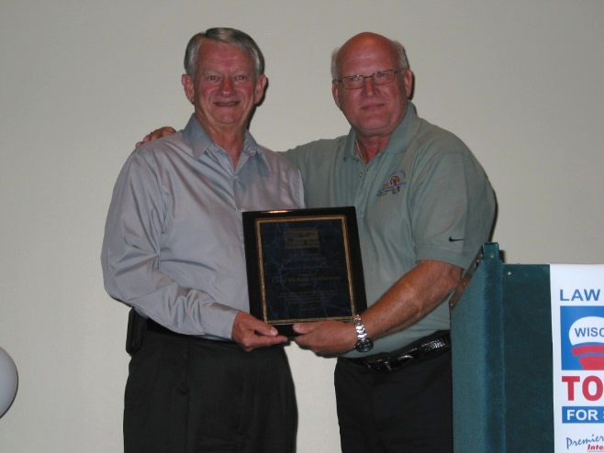

**SELECTION:**

An individual, a law enforcement agency or a Special Olympics program may submit nominations/applications. All nominations and/or applications should include a completed nomination form that is provided in this packet. There may be one or more inductees per year, to provide for the growing number of quality applicant and/or nominees. The Selections Committee determines the decision as to the number of inductees and the selection.

**CRITERIA:**

The nominee’s involvement shall demonstrate a **sustained and significant contribution** to the achievement of the goals of the Law Enforcement Torch Run®. The minimum requirements for this award are at least five (5) years of participation with the Torch Run, achievement in program development, organization and fund raising success. (We recognize our athletes in numerous ways, including leadership awards such as the Mike Schulte Athlete Leadership Award and the Special Olympics Male and Female athlete of the year’s awards; therefore they are not eligible for this award.)

**PROCESS:**

Nominees whom are not selected will remain in consideration for one (1) additional year (total of 2 years – year nominated plus one year). Supportive nominee information may be supplied each year. At the end of two (2) years, nominees’ files will be removed unless re-nominated using the current year’s nomination form.

All nominations or inductees will be kept confidential with inductees being announced at the Law Enforcement Torch Run® Celebration Party on Thursday, June 7, 2018 in Stevens Point.

All nominees will receive a letter of recognition from the Chair of the Selections Committee in honor of their nomination with a copy to the nominee’s agency.

**All 2021 Nomination Forms must be returned by May 8, 2022 to:**

**Joe Seubert**

**LETR Liason**

jseubert@specialolympicswisconsin.org

******Wisconsin Law Enforcement Torch Run®**

**Dale Brunner Hall of Fame Award**

**Nomination Form**

**Nominee Information:**

|  |  |
| --- | --- |
| Rank/Title and Name of Nominee: |  |
| Cell Phone: |  |
| Fax: |  |
| Law Enforcement Agency: |  |
| Business Address: |  |
| City, State & Zip: |  |
| E-mail Address: |  |
| Nominee’s Supervisor’s Contact Information including Name/Phone number/E-mail address: |  |

**Criteria for this award:**

The nominee’s involvement must demonstrate a sustained and significant contribution to the achievement of the goals of the Law Enforcement Torch Run®. The minimum requirements for this award are at least five years of participation with the Torch Run, achievement in program development, organization and fund raising success.

|  |  |  |
| --- | --- | --- |
| 1. | How many years has the nominee been involved with the Torch Run? |  |
| 2A. | Please list the nominee’s involvement with **Special Olympics and the Torch Run**. Please be specific and highlight activities, positions held (coaching athletes, etc), accomplishments, length of service, money raised, sponsors acquired, etc. – Local involvement (town, city): |  |
| 2B. | Please explain any State or National involvement: |  |
| 2C. | Please explain any International involvement: |  |

|  |  |  |
| --- | --- | --- |
| 3. | What impact has this person had on furthering the mission of the Wisconsin Torch Run? |  |
| 4. | Please list any other information you believe the selection committee should know about the nominee. |  |
| 5A. | Has the nominee attended any International conferences? | □ Yes □ No |
| 5B. | If yes, what year(s): |  |

**Person Completing This Form:**

|  |  |
| --- | --- |
| Your Name: |  |
| Law Enforcement Agency/Organization: |  |
| Phone (day): |  |
| Fax: |  |
| E-mail Address: |  |
| Street Address |  |
| City, State, Zip: |  |
| Special Olympics Region: |  |
| Involvement with Torch Run (Regional Director/ Staff) |  |

**All 2021 Nomination Forms must be returned by May 8, 2022 to:**

**Joe Seubert**

**LETR Liason**

jseubert@specialolympicswisconsin.org