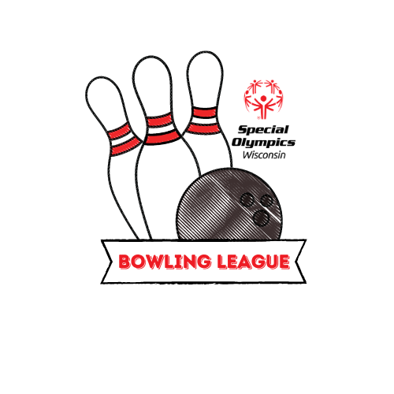

2023 FALL BOWLING LEAGUE

OPTIONS FOR COMPETITION:
1. Regional League Competition: Athletes will compete in five (5) weeks of league play. All athletes and unified partners will bowl two (2) games per week. Scores for missed weeks will be zero.

a) Athletes do not need a qualifying score to register for the SOWI Bowling League.

b) Divisions will be determined after two (2) weeks of competition. The four-game average will be used to division.

c) Scores must be submitted by the local program manager or coach each week by 11:59pm on Sunday.

2. Deadlines
Monday, October 2 Registration forms due by 11:59pm
Monday, October 9 Bowling League begins
Sunday, October 15 Week 1 scores due by 11:59pm
Sunday, October 22 Week 2 scores due by 11:59pm
Friday, October 27 Divisions Announced
Sunday, October 29 Week 3 scores due by 11:59pm
Sunday, November 5 Week 4 scores due by 11:59pm
Sunday, November 12 Week 5 (final) scores due by 11:59pm

OFFICIAL EVENTS OFFERED:
1. BOWLING
Event Code Event Description
BWLDEV Developmental Singles & Ramp (one athlete)
BOSINR Ramp - Single (one athlete)
BOSING Singles (one athlete)
BODBLE Doubles (two athletes)
BOTEAM Team (four athletes)
BODBLEU Unified Doubles (one athlete, one unified partner)
BOTEAMU Unified Team (two athletes, two unified partners)

ELIGIBILITY FOR FALL SPORTS SEASON PARTICIPATION
1. Valid Official Special Olympics Release Form and Application for Participation in Special Olympics Application on file in the Headquarters office by October 1, 2023. Athletes are not allowed to attend practice before the Special Olympics Wisconsin State Office has processed forms.

2. Unified Partners must have a valid Class A Volunteer Application on file with the State Office before attending practice.

3. Both athletes and unified partners must have a valid COVID-19 Participant Release Form and Communicable Disease Waiver on file in the State Office before attending practice.

4. There is no minimum practice time before participating in the 2023 Bowling League. Athletes do not need to submit a qualifying score with registration.

5. Individual bowlers using a ramp MUST be registered as a ramp bowler (BOSINR).

REGISTRATION
Registration form must be submitted to your Regional Athletic Director. After registration has been received, agency bowling contacts will receive weekly bowling score sheets with your active roster.

REGIONS 2 and 3
Submit registration and weekly score sheets to:
Kaytlin Kassens
KKassens@SpecialOlympicsWisconsin.org
Phone: 715-204-9696
Fax: 608-222-3578

REGIONS 4 and 5
Submit registration and weekly score sheets to:
Megan Quandt
mquandt@SpecialOlympicsWisconsin.org
Fax: 920-731-3691

REGION 6
Submit registration and weekly score sheets to:
Adam Loeber
ALoeber@SpecialOlympicsWisconsin.org
Phone: 608-442-5668
Fax: 608-222-3578

REGION 7
Submit registration and weekly score sheets to:
Brooke Trewyn
BTrewyn@SpecialOlympicsWisconsin.org
Phone: 262-241-7786
Fax: 262-649-3003

REGION 8
Submit registration and weekly score sheets to:
Amber Weinfurter
AWeinfurter@SpecialOlympicsWisconsin.org
Phone: 262-518-2314
Fax: 262-649-3003
2023 FALL BOWLING LEAGUE
LEAGUE REGISTRATION
Please Print Clearly:
Local Program Number: Local Program Name:
Head Coach: C: ( ) H: ( )
Address:
(City) (State) (Zip)
Fax: ( ) E-mail:
Additional email you would like games information sent to:
Select how you plan to submit weekly scores: Electronically in Excel Spreadsheet Handwritten Emailed/Faxed Copy
**Weekly league updates and information will only be sent to the email addresses listed above.

Return this form to THE APPROPRIATE ATHLETIC DIRECTOR BY MONDAY, october 3 AT 11:59PM

I have verified that all chaperones attending weekly league play are approved SOWI Class A certified volunteers (check √).

Reminder: Athlete to coaches/chaperone ratio is minimum of 4:1. Athletes can be entered in only one event.

 | Athlete Names  (Alphabetical: Last Name, First) | Event Code | ROLE  (athlete / unified partner) | team or doubles name  15 character limit
1.
2.
3.
4.
5.
6.
7.
8.
9.
10.
11.
12.
13.
14.
15.
16.
17.
18.
19.
20.
21.
22.
23.
24.
25.
26.
27.
28.
29.
30.
31.
32.
33.
34.
35.
36.
37.
38.

